Matcha Chiffon Cake
https://cookpad.com/recipe/1442190

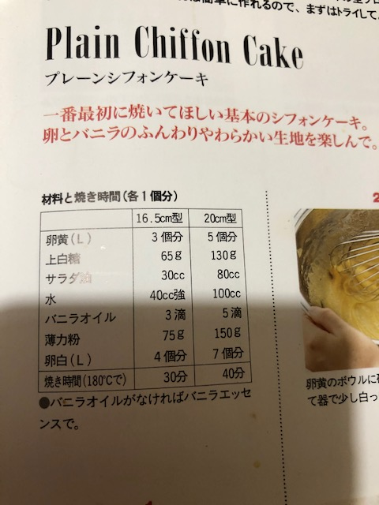

Submitted by: Himari T.

