-0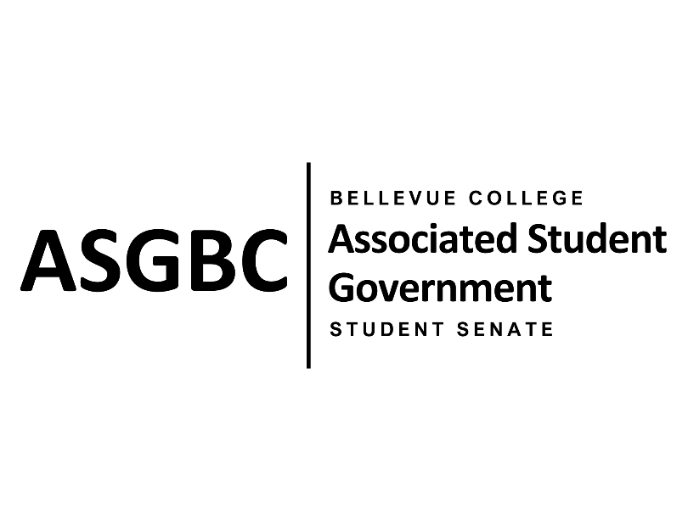

ASG Student Senate Meeting Agenda
May 28th, 2024 | N-201| 5:30-7
Next Meeting: June 4th, 2024

- CALL TO ORDER
  - Rebecca Mbaka calls the meeting to order at 5:34pm.

- ROLL CALL
  - Speaker: Rebecca Mbaka (present)
  - Vice Speaker: Stephanie Nehema (present)
  - Clerk: Sienna Jarrard (present)
  - Arts and Humanities Senator: Katrina Gunvaldson (present)
  - Business and Technology: Zoe Mukaba (absent, excused)
  - Health Science, Education, and Wellness Institute: Cornelie Aloma (absent, excused)
  - Social Science: Adam Gong (present)
  - Science: Marita Bwalya (absent, excused)
  - Housing: Lucy Ju (present)
  - Athletics: Kes Smith (present)
  - Running Start: Mumina Guled (present)
  - International: Graciella Nzowo (present)
  - At-Large: Merveil Kalala (present)
  - At-Large: Daniella Salima (absent, excused)
  - At-Large: Marie Lumiere Kawende (present)
  - At-Large: Emmanuel Ngoie (present)
  - At-Large: Vallon Bosango (present)

- INTRODUCTIONS
  - Sean Behl- ASG President

- APPROVAL OF AGENDA
  - Marie Lumiere Kawende motions, Emmanuel Ngoie seconds, motion passes by (9-0-0)
- APPROVAL OF MINUTES
  - Vallon Bosango motions, Marie Lumiere Kawende seconds, motion passes by (9-0-0)
- OPEN FORUM
- REPORTS
  - Rebecca Mbaka reached out to Ty Bergstrom regarding the rental costs and hourly minimums resolution, she sent the athletic trainer resolution but hasn’t heard back yet.
- UNFINISHED BUSINESS
  - SR-01-15: A Resolution to Create Detailed Internal Building Maps
    - Katrina Gunvaldson and Mumina Guled present a resolution to create detailed internal maps of each building, showing room numbers, bathrooms, water fountains, stairs, elevators, faculty office numbers, etc. and their location.
    - The resolution requests that Bellevue College Institutional Advancement create these maps.
    - Marie Lumiere Kawende motions to approve the resolution, Emmanuel Ngoie seconds, motion passes by (9-0-0)
  - SR-01-16: A Resolution to Address the Schedule of the ELI Program
    - Marie Lumiere Kawende and Zoe Mukaba present a resolution to address the sehedule of the ESL program.
    - The resolution requests the International Education department to review the program schedule to make it more flexible and convenient for students.
    - Graciella Nzowo motions to approve the resolution, Vallon Bosango seconds, motion passes by (8-0-1)
  - SR-01-17: A Resolution to Enable International Students to Rate Their Immigration Advisors
    - Graciella Nzowo, Merveil Kalala, Daniella Salima, Vallon Bosango, and Emmanuel Ngoie present a resolution to allow international students to rate and give feedback on their immigration advisors.
    - The resolution requests Bellevue College to create a formal system for rating at the end of each academic term, for feedback to be reviewed by the International Education Department and create protocol to address recurring issues.
    - Marie Lumiere Kawende motions to approve the resolution, Emmanuel Ngoie seconds, motion passes by (9-0-0)
  - SR-01-18: A Resolution to Address Outdoor Walkway Conditions on Campus
    - Adam Gong and Sienna Jarrard present a resolution to address dirty floors across campus outdoor community areas.
    - The resolution requests Bellevue College Campus Operations adopt a more frequent cleaning schedule and target outdoor community spaces to ensure they’re clean and useable.
    - Daniella Salima motions to approve the resolution, Marie Lumiere Kawende seconds, motion passes by (9-0-0)
- NEW BUSINESS
  - SR-01-19: A Resolution to Improve the Student Life Experience by Installing New Umbrellas and Repairing or Replacing the Existing Ones
    - Vallon Bosango and Kes Smith present a resolution to address the damaged outdoor umbrellas outside the C-Building.
    - The resolution requests that the umbrellas are repaired or replaced to prevent injuries and enhance the student experience.
    - Vallon Bosango motions to refer the resolution to the Board of Directors for review, Emmanuel Ngoie seconds, motion passes by (9-0-0)
  - SR-01-20: A Resolution to Improve the Student Life Experience by Repairing or Replacing the Broken Water Fountains on Campus
    - Vallon Bosango and Kes Smith present a resolution to address the broken water fountains on campus.
    - The resolution requests that the water fountains be replaced or repaired to provide better access to water on campus.
    - Sienna Jarrard motions to table the resolution indefinitely, Marie Lumiere Kawende seconds, motion by passes (9-0-0)
  - SR-01-21: A Resolution to Improve the Student Life Experience by Replacing the Torn Chairs in the L-building Sitting Area
    - Vallon Bosango and Kes Smith present a resolution to address the ripped seating covers on the first floor of the L-Building.
    - The resolution request that the chairs either be repaired or replaced.
    - Vallon Bonsango motions to refer the resolution to the Board of Directors for review, Katrina Gunvaldson seconds, motion passes by (9-0-0).
- DISCUSSION ITEMS
  - International Night Market
  - ASG End of Year Celebration- June 14th 1-3pm in N201
  - ASG Gala- June 6th 5-10pm in U301
- ANNOUNCEMENTS
  - Vallon Bosango announces the PTK Cabaret event in the Cafeteria on May 29th from 12-3pm. There will be a talent showcase, pizza, pastries, and drinks.
- ADJOURNMENT
  - Vallon Bosango motions to adjourn the meeting, Marie Lumiere Kawende seconds, motion passes by (9-0-0), Rebecca Mbaka adjourns the meeting at 6:53pm.

