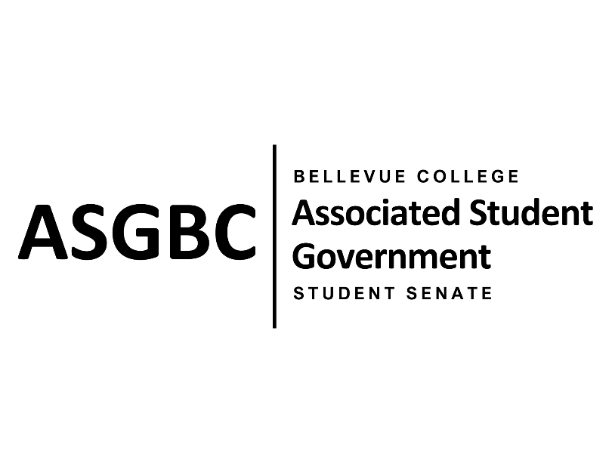

ASG Student Senate Meeting Agenda
May 21st, 2024 | N-201| 5:30-7
Next Meeting: May 28th, 2024

- CALL TO ORDER
  - Rebecca Mbaka calls the meeting to order at 5:32pm

- ROLL CALL
  - Speaker: Rebecca Mbaka (present)
  - Vice Speaker: Stephanie Nehema (present)
  - Clerk: Sienna Jarrard (absent, excused)
  - Arts and Humanities Senator: Katrina Gunvaldson (present)
  - Business and Technology: Zoe Mukaba (present)
  - Health Science, Education, and Wellness Institute: Cornelie Aloma (absent, unexcused)
  - Social Science: Adam Gong (present)
  - Science: Marita Bwalya (present)
  - Housing: Lucy Ju (absent, unexcused)
  - Athletics: Kes Smith (present)
  - Running Start: Mumina Guled (present)
  - International: Graciella Nzowo (present)
  - At-Large: Merveil Kalala (absent, excused)
  - At-Large: Daniella Salima (present)
  - At-Large: Marie Lumiere Kawende (present)
  - At-Large: Emmanuel Ngoie (present)
  - At-Large: Vallon Bosango (present)

- INTRODUCTIONS
  - Amy McCrory- ASG and Senate Advisor
  - Sean Behl- ASG President
  - Joyce Diakubama- ASG Public Relations Representative
  - Daniel Ngoy- ASG Executive Justice

- APPROVAL OF AGENDA
  - Marie Lumiere Kawende motions, Marita Bwalya seconds, motion passes by (11-0-0)
- APPROVAL OF MINUTES
  - Marie Lumiere Kawende motions, Emmanuel Ngoie seconds, motion passes by (11-0-0)
- OPEN FORUM
- REPORTS
- UNFINISHED BUSINESS
- NEW BUSINESS
  - SR-01-15: A Resolution to Create Detailed Internal Building Maps
    - Katrina Gunvaldson and Mumina Guled present a resolution to create detailed internal maps of each building, showing room numbers, bathrooms, water fountains, stairs, elevators, faculty office numbers, etc. and their location.
    - The resolution requests that Bellevue College Institutional Advancement create these maps.
    - Emmanuel Ngoie motions to refer the resolution to the Board of Directors for review, Marie Lumiere Kawende seconds, motion passes by (11-0-0)
  - SR-01-16: A Resolution to Address the Schedule of the ESL Program
    - Marie Lumiere Kawende and Zoe Mukaba present a resolution to address the sehedule of the ESL program.
    - The resolution requests the International Education department to review the program schedule to make it more flexible and convenient for students.
    - Daniella Salima motions to amend the resolution to say “ELI” instead of “ESL”, Marita Bwalya seconds, motion passes by (11-0-0)
    - Katrina Gunvaldson motions to refer the resolution to the Board of Directors for review, Daniella Salima seconds, motion passes by (11-0-0)
  - SR-01-17: A Resolution to Enable International Students to Rate Their Immigration Advisors
    - Graciella Nzowo, Merveil Kalala, Daniella Salima, Vallon Bosango, and Emmanuel Ngoie present a resolution to allow international students to rate and give feedback on their immigration advisors.
    - The resolution requests Bellevue College to create a formal system for rating at the end of each academic term, for feedback to be reviewed by the International Education Department and create protocol to address recurring issues.
    - Daniella Salima motions to amend the resolution to change Jean D’Arc’s title, Marie Lumiere Kawende seconds, motion passes by (11-0-0)
    - Katrina Gunvaldson motions to refer the resolution to the Board of Directors for review, Daniella Salima seconds, motion passes by (11-0-0)
  - SR-01-18: A Resolution to Address Dirty Floor
    - Adam Gong and Sienna Jarrard present a resolution to address dirty floors across campus outdoor community areas.
    - The resolution requests Bellevue College Campus Operations adropt a more frequent cleaning schedule and target outdoor community spaces to ensure they’re clean and useable.
    - Daniella Salima motions to refer the resolution to the Board of Directors for review, Marie Lumiere Kawende seconds, motion passes by (11-0-0)
- DISCUSSION ITEMS
  - Course Syllabi
    - Sean Behl presents discussion over accurate resources, room numbers, titles, and offices being present in course syallbi.
  - ASG End of Year Celebration- June 14th 1-3pm in N201
    - This event will introduce the new and current ASG and is mandatory for all Senate members.
  - ASG Gala- June 6th 5-10pm in U301
    - This event is to celebrate student accomplishments this academic year and is mandatory for all Senate members.
- ANNOUNCEMENTS
  - Sean Behl announces that the Student Trustee application is currently open for the 2024-2025 Academic Year and he encourages all to apply.
- ADJOURNMENT
  - Daniella Salima motions, Marie Lumiere Kawende seconds, motion passes by (11-0-0), Rebecca Mbaka adjourns the meeting at 6:24pm.

