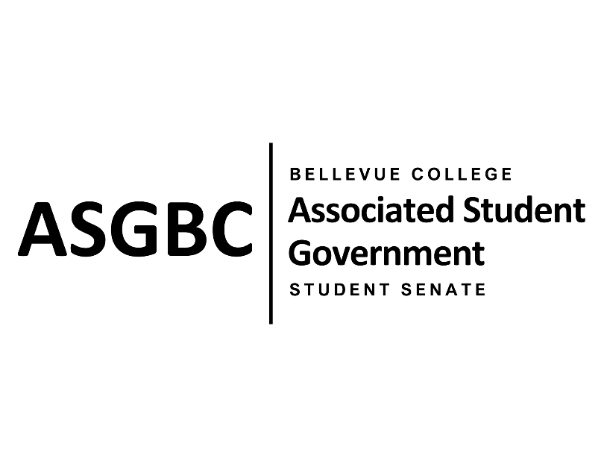

ASG Student Senate Meeting Agenda
April 30th, 2024 | N-201| 5:30-7
Next Meeting: May 7th, 2024

- CALL TO ORDER
  - Rebecca Mbaka calls the meeting to order at 5:34pm.

- ROLL CALL
  - Speaker: Rebecca Mbaka (present)
  - Vice Speaker: Stephanie Nehema (present)
  - Clerk: Sienna Jarrard (present)
  - Arts and Humanities Senator: Katrina Gunvaldson (present)
  - Business and Technology: Zoe Mukaba (present)
  - Health Science, Education, and Wellness Institute: Cornelie Aloma (present)
  - Social Science: Adam Gong (tardy)
  - Science: Marita Bwalya (present)
  - Housing: Lucy Ju (absent, arrive at 5:46pm)
  - Athletics: Kes Smith (present)
  - Running Start: Mumina Guled (present)
  - International: Graciella Nzowo (tardy)
  - At-Large: Merveil Kalala (present)
  - At-Large: Daniella Salima (present)
  - At-Large: Marie Lumiere Kawende (present)
  - At-Large: Emmanuel Ngoie (present)
  - At-Large: Vallon Bosango (present)

- INTRODUCTIONS
  - Sean Behl- ASG President
  - Amy McCrory- ASG and Senate Advisor

- APPROVAL OF AGENDA
  - Daniella Salima motions, Marie Lumiere Kawende seconds, motion passes by (11-0-0)
- APPROVAL OF MINUTES
  - Emmanuel Ngoie motions, Marie Lumiere Kawende seconds, motion passes by (11-0-0)
- OPEN FORUM
  - The Academic Success Center Fee is no longer apart of SB-01-01 as the Academic Success Center needs more to time to look at their own operations and operating cost.
- REPORTS
  - Rebecca Mbaka has been working on sending SR-01-11 and SR-01-12 to their respective recipients after being passed by the Board of Directors. A few people have responded saying they would look more into the issues that have been brought up. A few Senators still need to schedule their one-on-one meetings.
- UNFINISHED BUSINESS
  - SR-01-06: A Proposal for Consistent and Regular (Monthly) Technical Maintenance Checks across the Campus.
    - Marita Bwalya and Marie Lumiere Kawende present a resolution to suggest a more frequent technical maintenance check of the computers and printers on campus.
    - The resolution requests that the Bellevue College Technology Service Desk implement regular maintenance checks and provide a system to easily report and track technical issues.
    - Emmanuel Ngoie motions to table to the next meeting, Daniella Salima seconds, motion passes by (14-0-0)
  - SB-01-01: A Recommendation to the Board of Directors to Enact Nominal Voluntary Student Fees to Ensure the Sustainability of the Services and Activities Fee Process.
    - Sienna Jarrard presents a bill to recommend the Board of Directors to enact nominal voluntary fees.
    - The bill requests that the Associated Student Government of Bellevue College Board of Directors enact a voluntary fee to support the ASGBC Office of Civic Engagement, and the membership dues of the Washington Student Association. It also recommends the establishment of a committee to oversee all voluntary student fees and to further work with the administration to find alternative sources of funding.
    - Vallon Bosango motions to approve the resolution, Marita Bwalya seconds, motion passes by (13-1-0)
  - SR-01-13: A Resolution to Address Rental Costs and Hourly Minimums for Students on the 3rd Floor of the U-Building
    - Sienna Jarrard presents a resolution to address rental costs and hourly minimums for students to use rooms on the 3rd floor of the U-Building.
    - The resolution requests Bellevue College Eevnts and Facilities Rentals reconsider the pricing and 4-hour minimum for students to rent out the spaces.
    - Daniella Salima motions to approve the resolution, Marie Lumiere Kawende seconds, motion passes by (14-0-0)
- NEW BUSINESS
  - SR-01-14: A Resolution to Address Inadequate Access to Athletic Trainers for Student-Athletes
    - Kes Smith presents a resolution to address the inadequate access to athletic trainers for student-athletes.
    - The resolution requests that Bellevue College hires and maintains at least 3 full-time or full-time equivalent athletic trainers to meet the recommendations of the National Athletic Training Association Guidelines.
    - Marie Lumiere Kawende motions to refer the resolution to the Board of Directors for review, Emmanuel Ngoie seconds, motion passes by (14-0-0)
- DISCUSSION ITEMS
  - Voting Events Volunteers Needed
    - May 6-9th ASGBC is holding voting events from 11am to 2pm in the Theatre Courtyard where student who have voted in the election can get free food from food trucks.
  - Quarterly Reports
    - Quarterly reports were due on April 16th, any Senator who has not submitted must submit as soon as possible.
- ANNOUNCEMENTS
  - No announcements
- ADJOURNMENT
  - Stephanie Nehema motions, Daniella Salima seconds, motion passes by (13-1-0), Rebecca Mbaka adjourns the meeting at 7:03pm.

