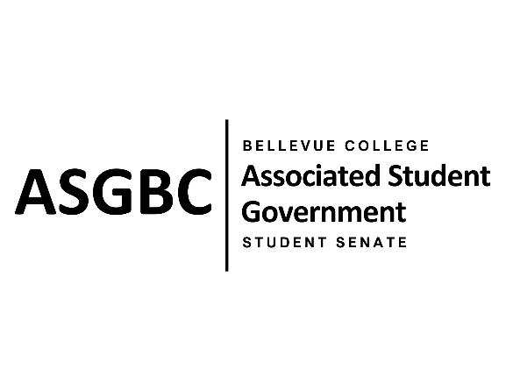
STUDENT SENATE
Session I
Date: June 4th, 2024
SR-01-22

Submitted by Mumina Guled, Kes Smith
Sponsored by Graciella Nzowo

SENATE RESOLUTION SR-01-22: A Suggestion to Implement a Running Start and Transfer Student Alumni Support Program
WHEREAS: Many Bellevue College students go through the process of completing college applications whether through the running start program or as transfer students; and,

WHEREAS: Academic advising services at Bellevue College mainly provides support for students related to their current coursework and may not fully address the specific needs of students preparing to transfer and/or apply to universities; and,

WHEREAS: Alumni of Bellevue College often have valuable and relevant experience that can greatly benefit current students in overcoming these challenges; and,

WHEREAS: Students would greatly benefit from support beyond advising staff, specifically from alumni who have already successfully undergone the college application process and can offer more specific insight; and,

THEREFORE, BE IT RESOLVED BY THE ASSOCIATED STUDENT GOVERNMENT OF BELLEVUE COLLEGE

THAT: Bellevue College creates a dedicated support program for students undergoing the university application process that hosts information sessions around the Common App, provides instructions on how to report coursework, and allows students to schedule one-on-one advising with alumni volunteers; and,

THAT: Bellevue College reaches out to alumni to participate in this program, utilizing the Bellevue College Alumni Association through emails and social media, and that surveys be sent out to graduating running start and transfer students to gauge interest in whether students would want to become future alumni volunteers; and,

THAT: A copy of this legislation be sent to the Bellevue College Alumni Association, Bellevue College University Transfer Center, Bellevue College Foundation and the Bellevue College Academic Advising Department.

End
________________________________ |  | __________________________________
Sean Behl  ASG President |  | Rebecca Mbaka  Speaker of the Senate

