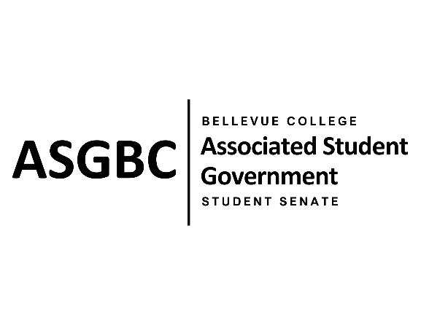
STUDENT SENATE
Session I
Date: June 4, 2024
SR-01-19

Submitted by Vallon Bosango
Sponsored by Kes Smith, Sienna Jarrard

SENATE RESOLUTION SR-01-19: A Resolution to Improve the Furniture Conditions on Campus
WHEREAS: Students frequently utilize the sitting areas and other spaces on campus to relax, socialize, eat, or do homework; and,

WHEREAS: The outdoor sitting area along the C-Building is equipped with tables, chairs, and umbrellas. However, some of these tables have missing and unmaintained umbrellas, including one with a broken sharp metallic umbrella stick sticking out and endangering student safety. This continuous exposure to potential injuries is particularly concerning due to the frequent use of the sitting area; and,

WHEREAS: The L-Building offers a furnished seating area on the first floor. However, almost all the main chairs in this sitting area have torn surfaces exposing their inner materials, which makes them look unclean, untidy, and unappealing for students’ use.

THEREFORE, BE IT RESOLVED BY THE ASSOCIATED STUDENT GOVERNMENT OF BELLEVUE COLLEGE

THAT: The Bellevue College Campus Operations replace or repair the broken umbrellas to prevent injuries and enhance the on-campus experience; and,

THAT: The Bellevue College Office of Sustainability and Campus Operations replace or reupholster the furniture in the L-Building to improve the campus image and sitting experience; and,

THAT: A copy of this resolution be sent to Campus Operations and the Office of Sustainability.

End
________________________________ |  | __________________________________
Sean Behl  ASG President |  | Rebecca Mbaka  Speaker of the Senate

