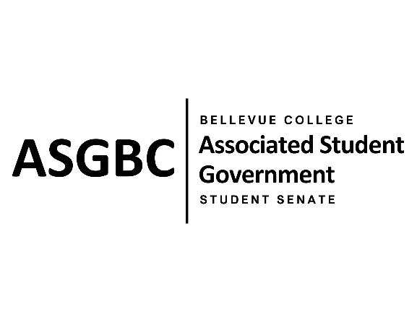
STUDENT SENATE
Session I
Date: May 31st, 2024
SR-01-16

Submitted by Marie Lumiere Kawende
Sponsored by Zoe Mukaba

SENATE RESOLUTION SR-01-16: A Resolution to Address the Schedule of the ELI Program.
WHEREAS: The ELI program schedule is extended from a period starting from 12:30pm until 4:30pm for all the levels within the program; and,

WHEREAS: This schedule creates a time conflict between the ELI program and when a majority of the on campus extra-curricular activities take place, which prevent students from the ELI program to fully participate in activities or being involve in clubs or student organization; and,

WHEREAS: The only students concerned or enrolled in the program are international students and, these students often benefit from a fast immersion into the campus life which typically promotes a better adaptation to the system, and develops a stronger connection to campus culture overall.

THEREFORE, BE IT RESOLVED BY THE ASSOCIATED STUDENT GOVERNMENT OF BELLEVUE COLLEGE

THAT: The Associated Student Government of Bellevue College recommends action be taken by the International Education department toward reviewing the ELI program schedule to make it more flexible and convenient for the students; and,

THAT: A copy of this legislation be sent to Jean D’arc Campbell, the Associate Vice-President of International Education, Global Initiative and Extended Learning, Dr. Jessica Clark, the Provost and Vice President of Academic Affairs; and Dr. David May, the President of Bellevue College.

End
________________________________ |  | __________________________________
Sean Behl  ASG President |  | Rebecca Mbaka  Speaker of the Senate

