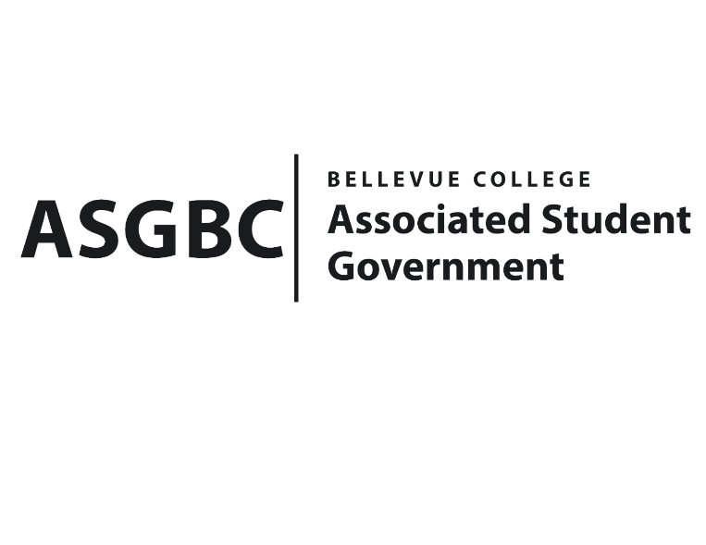

ASG Special Board of Directors Meeting MINUTES
April 2nd, 2024 | C-211/MS Teams| 3:00-3:30
Next Meeting: April 5th, 2024

- CALL TO ORDER
  - Chair Sean Behl calls the meeting to order at 3:05.

- ROLL CALL
  - President: Sean Behl (present)
  - Vice President: Rebecca Mbaka (absent-excused)
  - Executive Justice: Daniel Ngoy (present)
  - Treasurer: Heidi Ngo (present)
  - Secretary: Julie Nguyen (present)
  - Public Relations Rep: Joyce Diakubama (present)
  - Events Rep: Sienna Jarrard (present)
  - Social Responsibility Rep: Stephanie Nehema (present)
  - Emerging Technology Rep: Isadora Silva (absent-excused)

- INTRODUCTIONS
  - Mike Kaptik-Dean of Student Life and Leadership/ASG Advisor
- APPROVAL OF AGENDA
  - Heidi Ngo motions, Sienna Jarrard seconds, motion passes by (7-0-0)
- APPROVAL OF MINUTES
  - Daniel Ngoy motions, Heidi Ngo seconds, motion passes by (7-0-0)
- OPEN FORUM
  - There were no participants in the meeting interned in participating in open forum.
- REPORTS
  - President
    - Reports were tabled for this meeting at the direction of Chair Sean Behl
- UNFINISHED BUSINESS
- NEW BUSINESS
  - BOARD BILL 01-01-03: An Act to Amend the ASGBC Constitution
    - Sienna Jarrard motions, Daniel Ngoy seconds, motion passes by (6-0-1), Sean Behl abstains.
- DISCUSSION ITEMS
  - There were no discussion items.
- ANNOUNCEMENTS
  - There were no announcements.
- ADJOURNMENT
  - Heidi Ngo motions, Joyce Diakubama seconds, the meeting is adjourned at 3:11.

