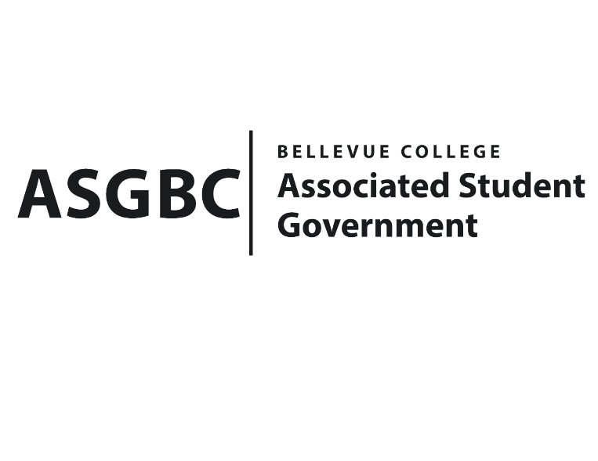
ASG Board of Directors Meeting Agenda
June 14th, 2024 | B-201 | 11:00-12:00
Final Meeting of Session I (2023-2024)

- CALL TO ORDER
  - Chair Sean Behl calls the meeting to order at

- ROLL CALL
  - President: Sean Behl (present)
  - Vice President: Rebecca Mbaka (present)
  - Executive Justice: Daniel Ngoy (present)
  - Treasurer: Heidi Ngo (present)
  - Secretary: Julie Nguyen (present)
  - Public Relations Rep: Joyce Diakubama (present)
  - Events Rep: Sienna Jarrard (present)
  - Social Responsibility Rep: Stephanie Nehema (present)
  - Emerging Technology Rep: Isadora Silva (present)

- INTRODUCTIONS
  - Name-Title (if applicable)
  - Name-Title (if applicable)

- APPROVAL OF AGENDA

- APPROVAL OF MINUTES

- OPEN FORUM

- REPORTS
  - President
    - The President has been…
  - Vice President
    - The Vice President has been…
  - Executive Justice
    - The Executive Justice has been…
  - Treasurer
    - The Treasurer has been…
  - Secretary
    - The Secretary has been…
  - Public Relations Rep.
    - The Public Relations Rep. has been…
  - Events Rep.
    - The Events Rep. has been…
  - Social Responsibility Rep.
    - The Social Responsibility Rep. has been…
  - Emerging Technology Rep.
    - The Emerging Technology Rep. has been…
- UNFINISHED BUSINESS
- NEW BUSINESS
  - BOARD BILL 04-01-57 - An Act to Approve the Charter of the Bellevue College Afro Dance Collective Club
  - BOARD BILL 04-01-58 - An Act to Approve the Charter of the Bellevue College Art & Design Club
  - Board Bill 01-01-04: An Act to Amend the ASGBC Bylaws
  - Board Bill 01-01-05: An Act to Amend the ASGBC Financial Code
  - Board Bill 03-01-82: An Act to Ratify the Student Environmental Sustainability Fee Committee’s Recommendation to Approve Funding for the ASGBC Course Material Voucher Program in the amount of $7,500
  - Board Bill 03-01-83: An Act to Ratify the Student Environmental Sustainability Fee Committee’s Recommendation to Approve Additional Funding for the Office of Sustainability to Purchase Electric Vehicles in the amount of $35,000
  - Board Bill 03-01-84: An Act to Ratify the Student Environmental Sustainability Fee Committee’s Recommendation to Approve Funding for the Wellness Center Costa Rica Global Wellness Experience in the amount of $60,500
  - Board Bill 03-01-85: An Act to Allocate Funding to Purchase Access to Canva for Employees of the ASGBC in the amount of $450
  - Board Bill 04-01-50: An Act to Adopt the ASGBC Office of Civic Engagement Policies and Procedures Manual
  - Board Bill 04-01-51: An Act to Adopt the ASGBC Office of Events and Community Relations Policies and Procedures Manual
  - Board Bill 04-01-52: An Act to Adopt the ASGBC Programs Manual
  - Board Bill 04-01-53: An Act to Establish the Voluntary Student Fee Oversight Committee
  - Board Bill 04-01-54: An Act to Establish the Student Commencement Speaker Selection Committee
  - Board Bill 04-01-55: An Act to Establish the Student Exemplary Achievement and Nobility Award Selection Committee
  - Board Bill 04-01-56: An Act to Delegate the Authority to the ASGBC President to Amend the Student Technology Fee, Student Environmental and Sustainability Fee Contracts, and to Adopt the Student Legislative Advocacy Fee Contract for a Limited Period.
  - SR-01-19: A Resolution to Improve Furniture Conditions on Campus
  - SR 01-22: A Resolution to Suggest the Implementation of a Running Start and Transfer Student Alumni Support Program
  - SR 01-23: A Resolution to Improve Menstrual Hygiene Options in Bellevue College Women's and Gender-Neutral Restrooms
- DISCUSSION ITEMS]
- ANNOUNCEMENTS
  - Board Member announces that…
- ADJOURNMENT

