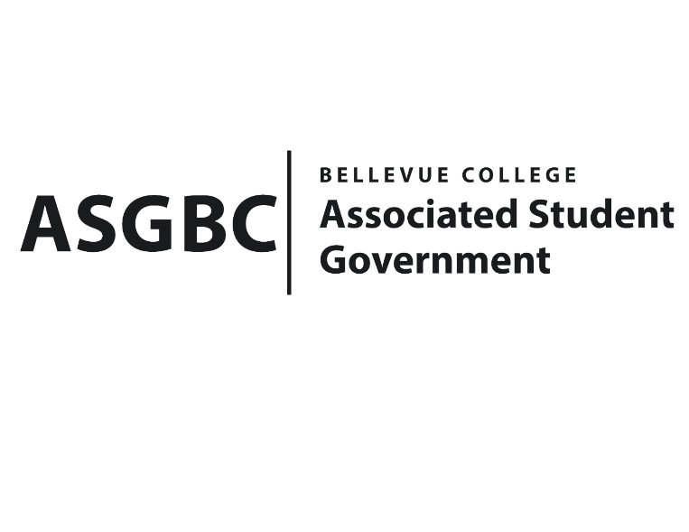
BOARD OF DIRECTORS
Session I
Date: June 14th, 2024
04-01-56

Submitted by Sean Behl, ASGBC President

BOARD BILL 04-01-56: An Act to Delegate the Authority to the ASGBC President to Amend the Student Technology Fee, Student Environmental and Sustainability Fee Contracts, and to Adopt the Student Legislative Advocacy Fee Contract for a Limited Period

WHEREAS: The newly adopted ASGBC Constitution states that the Board of Directors has the authority to “Delegate to committees or employees the power to act in specified areas without Board of Directors approval of those acts”.

WHEREAS: The Student Environmental Sustainability Fee Contract expired on June 30th, 2021, and contains a significant amount of outdated language; and,

WHEREAS: The Student Technology Fee Contract expired on June 30th, 2023, and contains a significant amount of outdated language; and,

WHEREAS: The Student Legislative Advocacy Fee requires a contract to be established between the college and the ASGBC to provide for rules on the oversight, collection, and expenditures of funds generated from the Student Legislative Advocacy Fee; and

THEREFORE, BE IT ENACTED BY THE ASSOCIATED STUDENT GOVERNMENT OF BELLEVUE COLLEGE BOARD OF DIRECTORS

THAT: The Board of Directors hereby delegates the authority to amend these contracts to the individual whom holds the office of the President of the Associated Student Government of Bellevue College from this date June 14th, 2024 until August 31st, 2024.

THAT: A copy of this bill be sent to Mike Kaptik; Dean of Student Life and Leadership/ASGBC Advisor, and Amy McCrory; ASGBC Advisor.

End

I, Sean Behl, President of the Associated Student Government of Bellevue College, do herby certify that Board Bill 04-01-56 was duly approved by the Board of Directors on 06/14/2024. I attest to the accuracy and authenticity of the contents of this bill.



__________________________________
Sean Behl
ASG President

