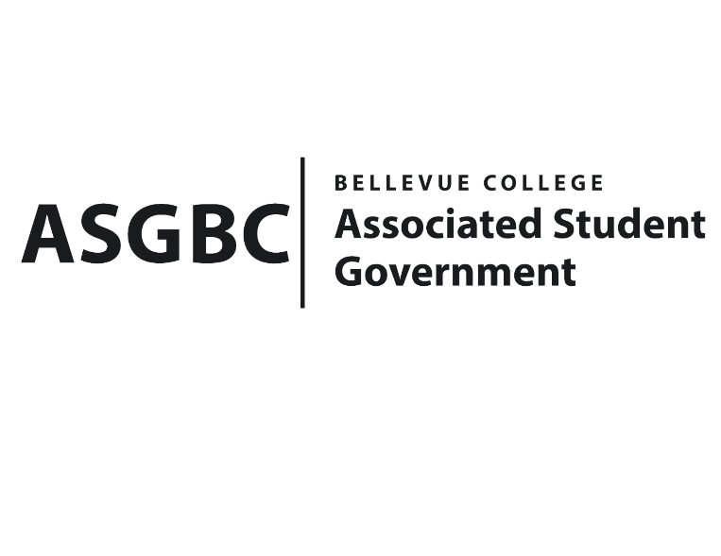
BOARD OF DIRECTORS
Session I
Date: June 14th, 2024
04-01-55

Submitted by Sean Behl, ASGBC President

BOARD BILL 04-01-55: An Act to Establish the Student Exemplary Achievement and Nobility Award Selection Committee

WHEREAS: The Associated Student Government of Bellevue College Board of Directors intends to establish the Student Exemplary Achievement and Nobility Award Selection Committee; and,

WHEREAS: The Student Exemplary Achievement and Nobility Award Selection Committee will be responsible for overseeing the selection process for the Student Exemplary Achievement and Nobility Award; and,

WHEREAS: The voting membership of the Student Exemplary Achievement and Nobility Award Selection Committee shall consist of the following individuals:
- The ASGBC Director of Events and Programs (or designee) shall serve as the Chair.
- The ASGBC President (or designee) who shall serve as Vice Chair.
- The Bellevue College President (or designee).
- One (1) ASGBC Student Senator appointed by the Chair.
- One (1) student-at-large appointed by the Chair.
- One (1) BC Faculty member appointed by the ASGBC President, in coordination with the Chair.
- One (1) BC Staff member appointed by the ASGBC President, in coordination with the Chair; and,

WHEREAS: The Student Exemplary Achievement and Nobility Award was created to honor the 2023-2024 ASGBC President Sean Behl for his work in restructuring the ASGBC, and for all of his dedication and outstanding contributions to not only the ASGBC, but the campus community at large; and,

WHEREAS: The award was presented to Sean Behl at the third annual ASGBC Gala on Thursday June 6th, 2024, by ASGBC Events Representative Sienna Jarrard and Bellevue College President Dr. David May.

THEREFORE, BE IT ENACTED BY THE ASSOCIATED STUDENT GOVERNMENT OF BELLEVUE COLLEGE BOARD OF DIRECTORS

THAT: The Associated Student Government of Bellevue College Board of Directors hereby establishes the Student Exemplary Achievement and Nobility Award Selection Committee; and,

THAT: A copy of this bill be forwarded to Mike Kaptik, Dean of Student Life and Leadership; and Amy McCrory, ASG Advisor.
End

I, Sean Behl, President of the Associated Student Government of Bellevue College, do herby certify that Board Bill 04-01-55 was duly approved by the Board of Directors on 06/14/2024. I attest to the accuracy and authenticity of the contents of this bill.



__________________________________
Sean Behl
ASG President

