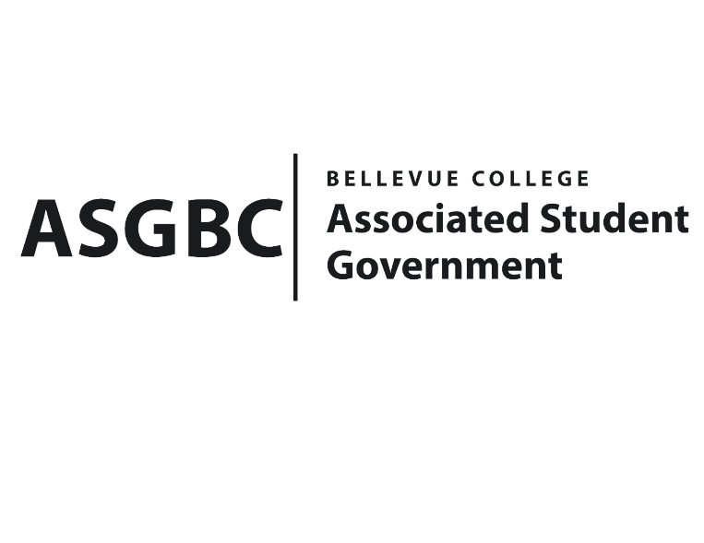
BOARD OF DIRECTORS
Session I
Date: June 14th, 2024
04-01-52

Submitted by Sean Behl, ASGBC President

BOARD BILL 04-01-52: An Act to Adopt the ASGBC Programs Manual

WHEREAS: The ASGBC has many programs that serve to benefit students at Bellevue College; and

WHEREAS: The ASGBC requires a dedicated manual to track, and organize the many programs currently being administered by the ASGBC; and,

WHEREAS: An ASGBC program is a structured initiative developed and managed by the ASGBC to enhance the student experience by addressing specific needs and providing essential services to the student body. These programs are characterized by their focus on student welfare, accessibility, and support, and are designed to improve various aspects of student life at Bellevue College; and,

WHEREAS: Sean Behl presents the ASGBC Programs Manual.

THEREFORE, BE IT ENACTED BY THE ASSOCIATED STUDENT GOVERNMENT OF BELLEVUE COLLEGE BOARD OF DIRECTORS

THAT: The Board of Directors hereby adopts the ASGBC Programs Manual as the dedicated governing document of the programs of the ASGBC; and,

THAT: A copy of this bill be sent to Mike Kaptik; Dean of Student Life and Leadership/ASGBC Advisor, and Amy McCrory; ASGBC Advisor.

End

I, Sean Behl, President of the Associated Student Government of Bellevue College, do herby certify that Board Bill 04-01-52 was duly approved by the Board of Directors on 06/14/2024. I attest to the accuracy and authenticity of the contents of this bill.



__________________________________
Sean Behl
ASG President

