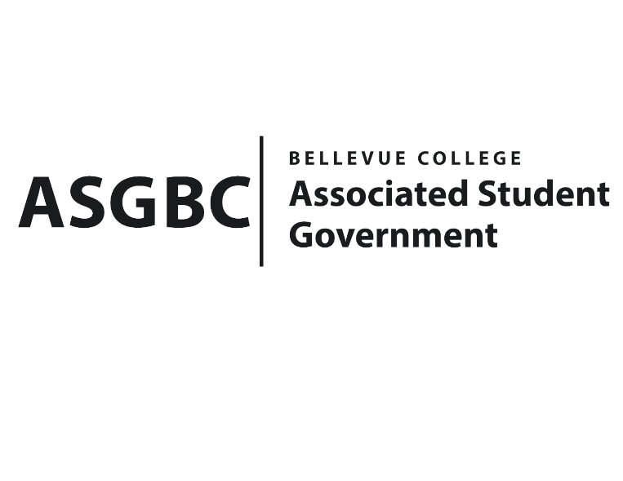
BOARD OF DIRECTORS
Session I
Date: June 7th, 2024
03-01-78

Submitted by Heidi Ngo Treasurer

BOARD BILL 03-01-78 - An Act to Approve Funding for the Jewish Student Union’s Event in the amount of $88.75.

WHEREAS: The Bellevue College Jewish Student Union plans to purchase food for their club meeting to create a place for Jewish students to meet and connect; and

WHEREAS: The Bellevue College Jewish Student Union’s club meeting aligns with their learning outcomes so that they can have a fulfilling connecting meal.

THEREFORE, BE IT ENACTED BY THE ASSOCIATED STUDENT GOVERNMENT OF BELLEVUE COLLEGE BOARD OF DIRECTORS

THAT: The Associated Student Government of Bellevue College approves the allocation of $88.75 to fund the Jewish Student Union’s funding request; and

THAT: The approved funding is allocated from the ASG Cultural account; and,

THAT: A copy of this bill be forwarded to Heid Ngo, Treasurer and Hristo Stoynov, Office of Student Engagement Program Coordinator, Rebecca Cory Jewish Student Union Club Advisor, and Kate Goldstein Jewish Student Union President.
End

I, Sean Behl, President of the Associated Student Government of Bellevue College, do herby certify that Board Bill 03-01-78 was duly approved by the Board of Directors on 06/07/2024. I attest to the accuracy and authenticity of the contents of this bill.


__________________________________
Sean Behl
ASG President

