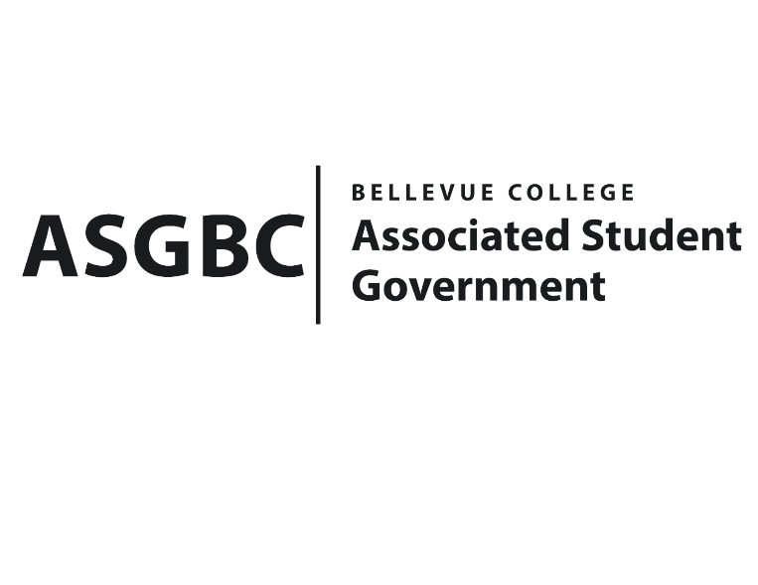
BOARD OF DIRECTORS
Session I
Date: May 31st, 2024
03-01-77

Submitted by Stephanie Nehema, Social Responsibility Representative

BOARD BILL 03-01-77: An Act to Approve SESF Recommendation on the Implementation of the ASGBC Student Shuttle Service.

WHEREAS: The ASGBC Student Shuttle Service is meant to serve the Bellevue College community and specifically students in housing, providing them access to off-campus resources without the need of their own car or being fully dependent on the transit system; and,

WHEREAS: The shuttle will run in a loop reaching multiple hub locations in the area including the Factoria Mall area, Crossroads Mall area, Downtown Bellevue, and Redmond Town Center, and will also be available for students to go to specific locations during allocated hours; and,

WHEREAS: This project addresses social issues as it provides access to transportation for those who are unable to drive or unable to purchase a car, and ensures equitable access to essential resources and locations for all students; and,

WHERAS: Bellevue has a robust transit system but lacks direct transportation options for students without cars, aside from costly rideshare services like Lyft and Uber, which may not be affordable for everyone;

THEREFORE, BE IT ENACTED BY THE ASSOCIATED STUDENT GOVERNMENT OF BELLEVUE COLLEGE BOARD OF DIRECTORS

THAT: The implementation of the ASGBC Student Shuttle Service be approved by the Board of Directors to cover the costs of the project; and,

THAT: A copy of this bill be forwarded to Sienna Jarrad, ASG Events Rep., Julie Nguyen, ASG Secretary; and Stephanie Nehema, ASG Social Responsibility Representative.

End
I, Sean Behl, President of the Associated Student Government of Bellevue College, do herby certify that Board Bill 03-01-77 was duly approved by the Board of Directors on 05/31/2024. I attest to the accuracy and authenticity of the contents of this bill.


__________________________________
Sean Behl
ASG President

