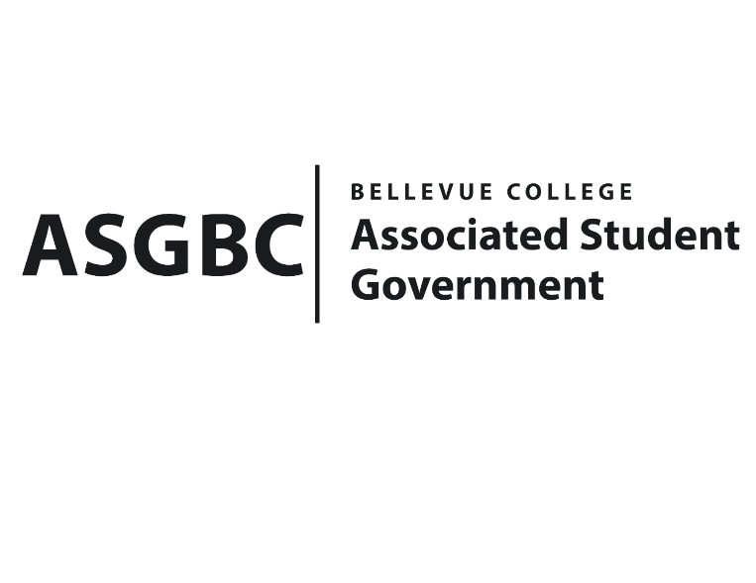
BOARD OF DIRECTORS
Session I
Date: May 31st , 2024
03-01-76

Submitted by Stephanie Nehema, Social Responsibility Representative

BOARD BILL 03-01-76: An Act to Ratify the SESF’s Recommendation to Approve Fall Sustainability Series Funding Request

WHEREAS: Throughout the fall, the Office of Sustainability organizes a series of workshops, documentaries, field trips, and other exciting activities to engage students and the BC community in climate justice and sustainability at the start of the school year, building a sustainability-minded community and providing free events for everyone to learn; and,

WHEREAS: The funding request will cover honorariums for speakers, field trip costs, and other free resources and opportunities for students, faculty, and staff, allowing the Fall Sustainability Series to touch on all aspects of sustainability, from climate justice to conservation and beyond; and,

THEREFORE, BE IT ENACTED BY THE ASSOCIATED STUDENT GOVERNMENT OF BELLEVUE COLLEGE BOARD OF DIRECTORS

THAT: The Board of Directors approves the funding request for the Fall Sustainability Series, covering honorariums for speakers, field trip costs, and other resources and opportunities for students, faculty, and staff.

THAT: A copy of this bill be forwarded to Sara, Director of Office of Sustainability Julie Nguyen, ASG Secretary; and Stephanie Nehema, ASG Social Responsibility Representative.

End
I, Sean Behl, President of the Associated Student Government of Bellevue College, do herby certify that Board Bill 03-01-76 was duly approved by the Board of Directors on 05/31/2024. I attest to the accuracy and authenticity of the contents of this bill.


__________________________________
Sean Behl
ASG President

