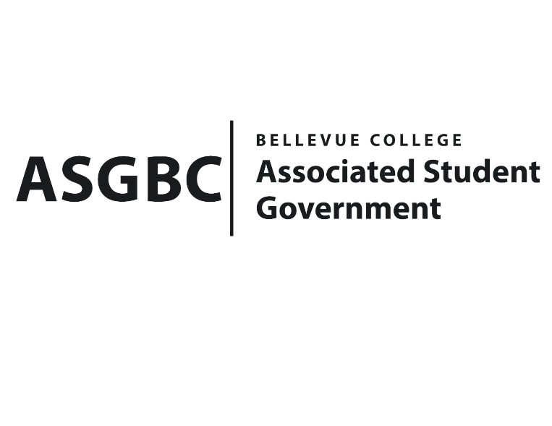
BOARD OF DIRECTORS
Session I
Date: May 31st , 2024
03-01-75

Submitted by Stephanie Nehema, Social Responsibility Representative

BOARD BILL 03-01-75: An Act to Ratify the SESF’s Recommendation to Approve the Bellevue College Electric Vehicles’s Purchase Funding Request in the amount of $92,586

WHEREAS: This proposal seeks funding for the purchase of 2 electric vehicles (EVs) for a pilot EV program on the BC campus; the vehicles would be a 2024 Ford E-Transit and 2024 Nissan Leaf, with the Ford E-Transit converted from a cargo van to a passenger van, with seating for 10-12 depending on the specific model purchased and configuration; and,

WHEREAS: The vehicles will be purchased at government pricing (discounted from MSRP) and are eligible for the direct-pay tax credit, which would return at minimum $7,500 per vehicle to Bellevue College. As the SESF would be funding the project, we propose that the tax credit funds be allocated towards future vehicle maintenance, insurance, and similar expenses.

WHEREAS: This project provides access to EVs for transportation, reducing greenhouse gas emissions and air pollution locally, bringing EVs into the community and encouraging EV use and adoption. Transportation is the primary source of carbon emissions on the BC campus, and this project aims to help decarbonize this area.

THEREFORE, BE IT ENACTED BY THE ASSOCIATED STUDENT GOVERNMENT OF BELLEVUE COLLEGE BOARD OF DIRECTORS

THAT: The Board of Directors approves the funding for the purchase of 2 electric vehicles (2024 Ford E-Transit and 2024 Nissan Leaf) for the pilot EV program on the BC campus.

THAT: The tax credit funds returned to Bellevue College from the purchase of these vehicles be allocated towards future vehicle maintenance, insurance, and similar expenses.

THAT: A copy of this bill be forwarded to Sara, Director of Office of Sustainability Julie Nguyen, ASG Secretary; and Stephanie Nehema, ASG Social Responsibility Representative.

End

I, Sean Behl, President of the Associated Student Government of Bellevue College, do herby certify that Board Bill 03-01-75 was duly approved by the Board of Directors on 05/31/2024. I attest to the accuracy and authenticity of the contents of this bill.


__________________________________
Sean Behl
ASG President

