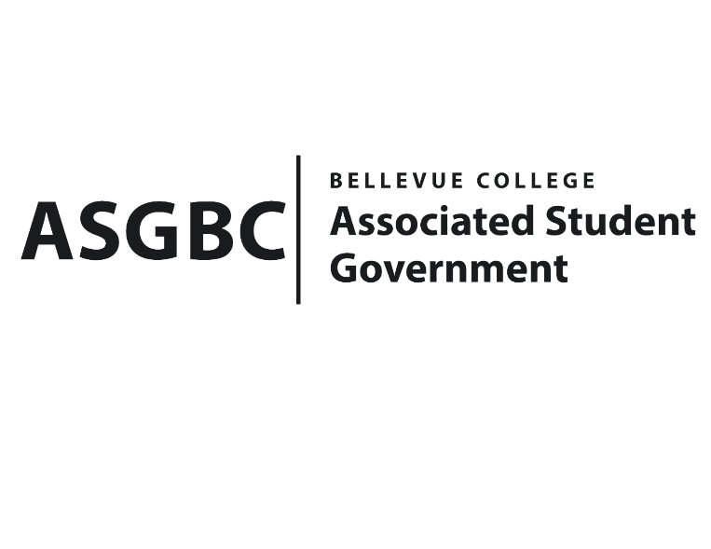
BOARD OF DIRECTORS
Session I
Date: May 31st , 2024
03-01-72

Submitted by Stephanie Nehema, Social Responsibility Representative

BOARD BILL 03-01-72: An Act to Ratify the Student Environmental Sustainability Fee Committee’s Recommendation to Approve Funding for Water Bottle Filler Stations in the amount of $30,000

WHEREAS: This project aims to provide supplemental funding to replace and add additional water bottle filler stations at Bellevue College to ensure equitable and accessible drinking water on campus; and,

WHEREAS: Many of the existing fountains are old models with outdated technology and need ADA compliance improvements, and the new outdoor stations will also be weatherized to ensure availability throughout the entire year and reduce the workload for the campus maintenance team; and,

WHEREAS: This project addresses sustainability and social/climate justice issues by providing upgraded and new water bottle filler stations, allowing more students to access free, filtered drinking water without needing to purchase bottled water, resolving accessibility issues, and ensuring ADA compliance; and,

WHEREAS: In 2023, 20 new water bottle fillers were installed, and there will be an additional 12 installed in this biennium, with Capital Projects funding $300,000 worth of new water bottle filler stations through the Capital Project Recommendation Committee funding request for Biennium 2023-2025, leaving $30,000 needed for the remaining 12 stations with contingency; and,

WHERAS: By minimizing the need to purchase bottled water, the filler stations will contribute to reducing single-use plastic on campus and support the campus's sustainability goals of reducing waste and reliance on plastics.

THEREFORE, BE IT ENACTED BY THE ASSOCIATED STUDENT GOVERNMENT OF BELLEVUE COLLEGE BOARD OF DIRECTORS

THAT: The Board of Directors approves the proposal for supplemental funding for water bottle filler stations to cover the remaining amount of $30,000, with contingency, to install a total of 12 new filler stations on campus.,

THAT: A copy of this bill be forwarded to Sara Holzknecht, Director of Office of Sustainability; Julie Nguyen, ASG Secretary; and Stephanie Nehema, ASG Social Responsibility Representative.

End

I, Sean Behl, President of the Associated Student Government of Bellevue College, do herby certify that Board Bill 03-01-72 was duly approved by the Board of Directors on 05/31/2024. I attest to the accuracy and authenticity of the contents of this bill.


__________________________________
Sean Behl
ASG President

