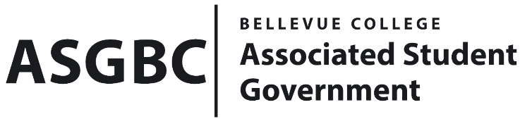
BOARD OF DIRECTORS
Session I
Date: May 31, 2024
03-01-68

Submitted by Heidi Ngo, ASG Treasurer

BOARD BILL 03-01-68: An Act to Ratify the STF Committee Recommendation for the ASGBC Charging Table Program in the Amount of $2500

WHEREAS: The ASGBC plans to establish the ASGBC Charging Table Program to provide students with access to charging cords and USB ports via a charging table placed in the C-Building Lobby; and,

WHEREAS: The STF Committee approved the allocation of $2500 for the ASGBC Charging Table Program on May 31st, 2024.

THEREFORE, BE IT ENACTED BY THE ASSOCIATED STUDENT GOVERNMENT OF BELLEVUE COLLEGE BOARD OF DIRECTORS

THAT: The Associated Student Government of Bellevue College approves the allocation of $2500 to fund the ASGBC Charging Table Program.

THAT: A copy of this bill be forward to Heidi Ngo, ASG Treasurer, Hristo Stoynov, Office of Student Engagement Program Coordinator, and the STF Committee.

End

I, Sean Behl, President of the Associated Student Government of Bellevue College, do herby certify that Board Bill 03-01-68 was duly approved by the Board of Directors on 05/31/2024. I attest to the accuracy and authenticity of the contents of this bill.


__________________________________
Sean Behl
ASG President

