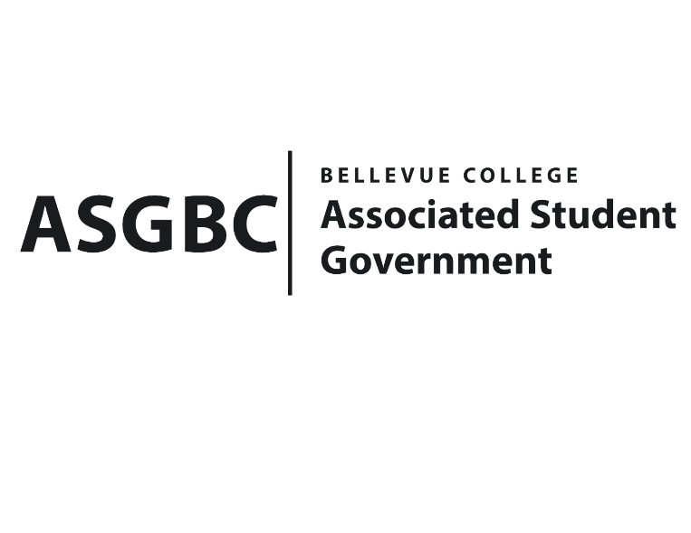
BOARD OF DIRECTORS
Session I
Date: May 31st, 2024
03-01-66

Submitted by Heidi Ngo Treasurer

BOARD BILL 03-01-66 - An Act to Approve Funding for the Rocketry Club’s Tri-City Workshop in the amount of $800.

WHEREAS: The Bellevue College Aerospace and Rocketry Club plans to go to the Tri-Cities Workshop to help finish getting their L1 certifications, which will allow them to buy parts for more advanced projects; and

WHEREAS: The Bellevue College Aerospace and Rocketry Club plans to use the funds to folding tables, disposable materials, and gas reimbursement.

THEREFORE, BE IT ENACTED BY THE ASSOCIATED STUDENT GOVERNMENT OF BELLEVUE COLLEGE BOARD OF DIRECTORS

THAT: The Associated Student Government of Bellevue College approves the allocation of $800.00 to fund the Aerospace and Rocketry Club funding request; and

THAT: The approved funding is allocated from the ASG General account; and,

THAT: A copy of this bill be forwarded to Heid Ngo, Treasurer and Hristo Stoynov, Office of Student Engagement Program Coordinator Trevor Gamble, Aerospace and Rocketry Club Advisor, and Issac Alschitz, Aerospace and Rocketry Club President.

End

I, Sean Behl, President of the Associated Student Government of Bellevue College, do herby certify that Board Bill 03-01-66 was duly approved by the Board of Directors on 05/31/2024. I attest to the accuracy and authenticity of the contents of this bill.


__________________________________
Sean Behl
ASG President

