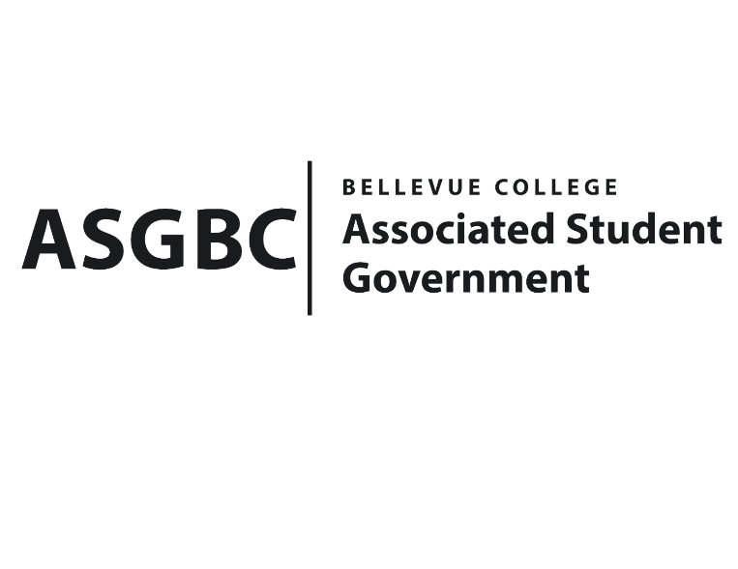
BOARD OF DIRECTORS
Session I
Date: May 24th, 2024
03-01-65

Submitted by Heidi Ngo Treasurer

BOARD BILL 03-01-65 - An Act to Approve Funding for the Indian Student Community’s Movie Event in the amount of $1500.00.

WHEREAS: The Bellevue College Indian Student Community plans to host a Bollywood movie night to celebrate Indian Culture and create a welcoming environment for members to be a part of; and

WHEREAS: The Bellevue College Stage Indian Student Community plans to purchase food, a movie and posters for their event.

THEREFORE, BE IT ENACTED BY THE ASSOCIATED STUDENT GOVERNMENT OF BELLEVUE COLLEGE BOARD OF DIRECTORS

THAT: The Associated Student Government of Bellevue College approves the allocation of $1500.00 to fund the Indian Student Community funding request; and

THAT: The approved funding is allocated from the ASG Cultural account; and,

THAT: A copy of this bill be forwarded to Heid Ngo, Treasurer and Hristo Stoynov, Office of Student Engagement Program Coordinator Leslie Lum Indian Student Community Advisor, and Diyah Shah, Indian Student Community President.

End

I, Sean Behl, President of the Associated Student Government of Bellevue College, do herby certify that Board Bill 03-01-65 was duly approved by the Board of Directors on 05/31/2024. I attest to the accuracy and authenticity of the contents of this bill.


__________________________________
Sean Behl
ASG President

