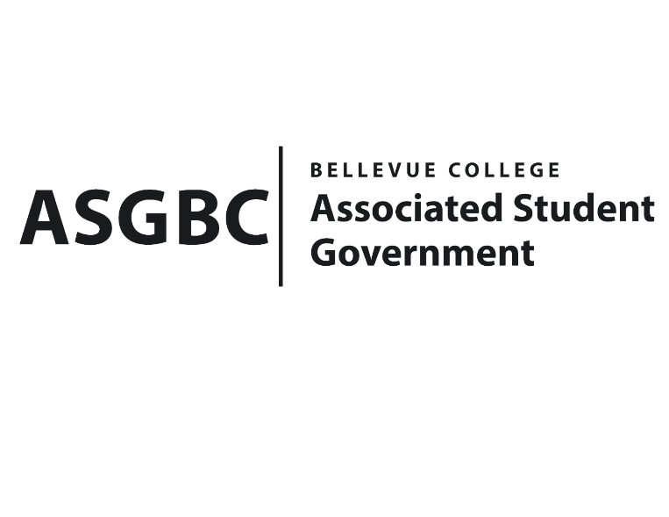
BOARD OF DIRECTORS
Session I
Date: May 31st, 2024
03-01-63

Submitted by Heidi Ngo Treasurer

BOARD BILL 03-01-63 - An Act to Approve Reallocation for the Academic Success Center in the amount of $4,500.00.

WHEREAS: The Bellevue College Academic Success Center plans to reallocate their other expenses to salaries and benefits; and

WHEREAS: The Bellevue College Academic Success Center received a generous allocation of $4,500 designated for account 5020003, earmarked for Grants, Scholarships, and Fellowships. However, the ASC does not currently administer a grants program. Accordingly, they respectfully request authorization to reallocate these funds from account 5020003 to account 5000130, designated for Higher Education Student Tutors.

THEREFORE, BE IT ENACTED BY THE ASSOCIATED STUDENT GOVERNMENT OF BELLEVUE COLLEGE BOARD OF DIRECTORS

THAT: The Associated Student Government of Bellevue College approves the reallocation of $4500.00 from the Academic Success Center’s other expenses; and

THAT: The approved funding is reallocated to the ASC’s Salaries and Benefits; and,

THAT: A copy of this bill be forwarded to Heid Ngo, Treasurer and Hristo Stoynov, Office of Student Engagement Program Coordinator, and Liz Warfield, Academic Success Center Advisor.

End

I, Sean Behl, President of the Associated Student Government of Bellevue College, do herby certify that Board Bill 03-01-63 was duly approved by the Board of Directors on 05/31/2024. I attest to the accuracy and authenticity of the contents of this bill.


__________________________________
Sean Behl
ASG President

