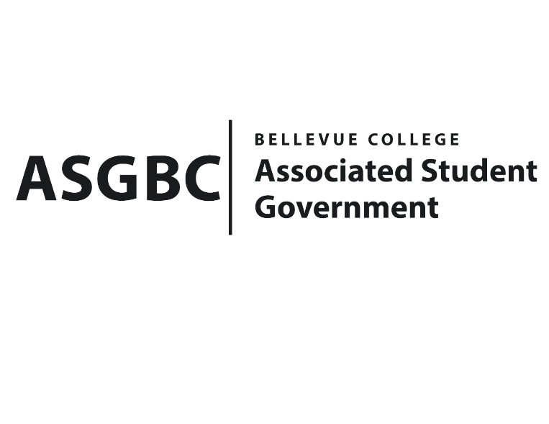

BOARD OF DIRECTORS
Session I
Date: May 24th, 2024
03-01-60

Submitted by Heidi Ngo Treasurer

BOARD BILL 03-01-60 - An Act to Approve Funding for the Model United Nations Organization’s National Conference in Washington DC in the amount of $12,362.16.

WHEREAS: The Bellevue College Model United Nations plans to attend to a national conference hosted in DC where BC representatives will engage in discussions with fellow participants as delegates of their assigned countries to talk about major world issues, ranging from human rights, public security, environment, etc. Students do research, actively voice out their opinions, and be willing to take in recommendations. This will help our members learn how the United Nations works to solve international issues and try the roles of diplomats; and

WHEREAS: The Bellevue College Model United Nations students will be able to train their communication, teamwork, and public speaking skills. Furthermore, they will be exposed to a circle of people from different states who harbor the same interests and passions as them. This provides students with the opportunity to network with those who may have similar ideas as they do. Lastly, students may be able to consolidate their future careers, and if there is an opportunity, students may visit the official embassy of their assigned country.

THEREFORE, BE IT ENACTED BY THE ASSOCIATED STUDENT GOVERNMENT OF BELLEVUE COLLEGE BOARD OF DIRECTORS

THAT: The Associated Student Government of Bellevue College approves the allocation of $12,362.16 to fund the Bellevue College Model United Nations funding request; and

THAT: The approved funding is allocated from the ASG General account; and,

THAT: A copy of this bill be forwarded to Heid Ngo, Treasurer and Hristo Stoynov, Office of Student Engagement Program Coordinator, Christina Sciabarra the Bellevue Model United Nations Advisor, and Daniella Salima The Bellevue College Model United Nations President.
End

I, Sean Behl, President of the Associated Student Government of Bellevue College, do herby certify that Board Bill 03-01-60 was duly approved by the Board of Directors on 05/24/2024. I attest to the accuracy and authenticity of the contents of this bill.

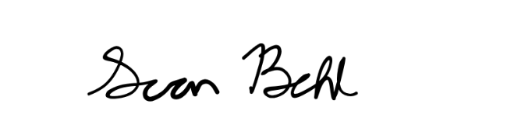
__________________________________
Sean Behl
ASG President

