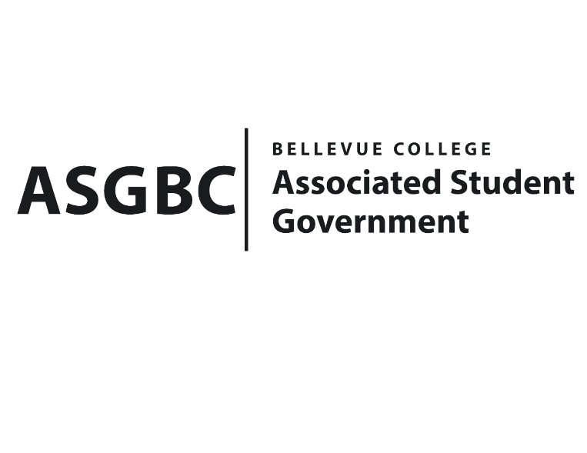
BOARD OF DIRECTORS
Session I
Date: May 24th, 2024
03-01-59

Submitted by Heidi Ngo Treasurer

BOARD BILL 03-01-59 - An Act to Approve Funding for the AI & Ethics Club’s Hiya tour & AI panel in the amount of $700.00.

WHEREAS: The Bellevue College AI & Ethics Club plans to go on a tour in Colombia Tower Seattle to connect with experts in the Ai field that are working in the growing startup tech field in Seattle; and

WHEREAS: The Bellevue College AI & Ethics Club hopes to foster an environment where they can provide opportunities to BC students in relation to the AI Field and provide them with networking opportunities with experts in the field. This event will help connect our AI and Ethics members with Hiya engineers as well as grow their knowledge on career options; and

WHEREAS: The Bellevue College AI & Ethics Club will expand their experience with companies and individuals the people they will connect with are highly experienced and can give them more knowledge on how to grow and learn more about organization through experience.

THEREFORE, BE IT ENACTED BY THE ASSOCIATED STUDENT GOVERNMENT OF BELLEVUE COLLEGE BOARD OF DIRECTORS

THAT: The Associated Student Government of Bellevue College approves the allocation of $700 to fund the Bellevue AI & Ethics Club funding request; and

THAT: The approved funding is allocated from the ASG General account; and,

THAT: A copy of this bill be forwarded to Heid Ngo, Treasurer and Hristo Stoynov, Office of Student Engagement Program Coordinator, Fatma Serce, The Bellevue College AI & Ethics Club Advisor, and Habiba Elswify, The Bellevue College AI & Ethics Club President.
End

I, Sean Behl, President of the Associated Student Government of Bellevue College, do herby certify that Board Bill 03-01-59 was duly approved by the Board of Directors on 05/24/2024. I attest to the accuracy and authenticity of the contents of this bill.


__________________________________
Sean Behl
ASG President

