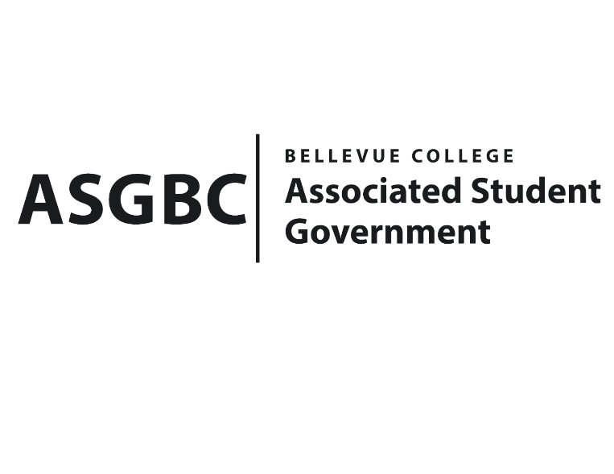
BOARD OF DIRECTORS
Session I
Date: May 24th, 2024
03-01-56

Submitted by Heidi Ngo Treasurer

BOARD BILL 03-01-56 - An Act to Approve Funding for the Student for Justice Club’s Guest Speaker Event in the amount of $3,500.00.

WHEREAS: The Bellevue College Students for Justice Club plans to host an event to foster a deeper understanding of global conflicts by providing a platform for individuals from diverse backgrounds and conflict zones, including Ukraine, Palestine, Congo, and Sudan, to share their experiences and perspectives. By bringing together speakers who have lived through these conflicts, they aim to amplify their voices, raise awareness, and inspire action towards peacebuilding and conflict resolution. Through dialogue, storytelling, and shared experiences, they seek to cultivate empathy, promote cross-cultural understanding, and highlight the resilience and courage of those affected by conflict around the world; and

WHEREAS: The Bellevue College Students for Justice Club activity will support their organization’s learning outcomes by improving participant’s understanding of global conflicts through firsthand stories from individuals in Ukraine, Palestine, Congo and Sudan. Hearing these personal accounts will build empathy and compassion, which are crucial addressing global issues. The event will also promote cross-cultural awareness by exposing attendees to different viewpoints, enhancing their global knowledge.

THEREFORE, BE IT ENACTED BY THE ASSOCIATED STUDENT GOVERNMENT OF BELLEVUE COLLEGE BOARD OF DIRECTORS

THAT: The Associated Student Government of Bellevue College approves the allocation of $3,500 to fund the Bellevue College Students for Justice Club funding request; and

THAT: The approved funding is allocated from the ASG General account; and,

THAT: A copy of this bill be forwarded to Heid Ngo, Treasurer and Hristo Stoynov, Office of Student Engagement Program Coordinator, Salam Awad, The Bellevue Students for Justice Club
Advisor, and Yousra Esseddiqi, The Bellevue College Students for Justice Club President.
End

I, Sean Behl, President of the Associated Student Government of Bellevue College, do herby certify that Board Bill 03-01-56 was duly approved by the Board of Directors on 05/24/2024. I attest to the accuracy and authenticity of the contents of this bill.


__________________________________
Sean Behl
ASG President

