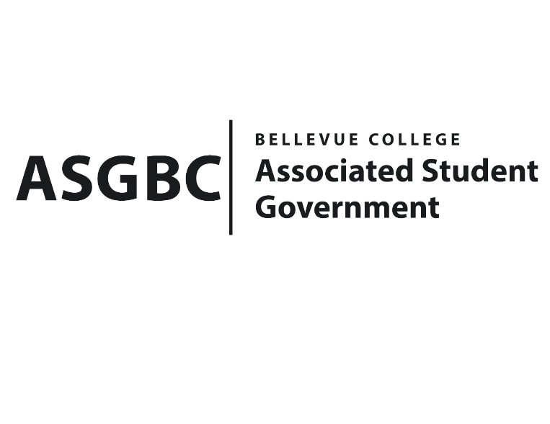
BOARD OF DIRECTORS
Session I
Date: May 10th, 2024
03-01-54

Submitted by Heidi Ngo Treasurer

BOARD BILL 03-01-54 - An Act to Approve Funding for the Taiwanese Student Association’s Food for Meetings in the amount of $1,018.00.

WHEREAS: The Bellevue College Taiwanese Student Association plans to have food for meetings to teach about different aspects of Taiwanese culture like food and drinks; and

WHEREAS: The Bellevue College Taiwanese Student Association’s activity will support their organization’s learning outcomes by persuading people to come to their meetings through the taste of Taiwanese food without having to travel to Taiwan; and

WHEREAS: The Bellevue College Taiwanese Student Association will support their missions and goals by giving people a chance to taste foods from Taiwan as they teach about various aspects of Taiwanese culture.

THEREFORE, BE IT ENACTED BY THE ASSOCIATED STUDENT GOVERNMENT OF BELLEVUE COLLEGE BOARD OF DIRECTORS

THAT: The Associated Student Government of Bellevue College approves the allocation of $1,018.00 to fund the Bellevue College Taiwanese Student Association funding request; and

THAT: The approved funding is allocated from the ASG Cultural account; and,

THAT: A copy of this bill be forwarded to Heid Ngo, Treasurer and Hristo Stoynov, Office of Student Engagement Program Coordinator, Taylor Dalrymple, The Bellevue Taiwanese Student Association Advisor, and Emily Liu, The Bellevue College Taiwanese Student Association President.

I, Sean Behl, President of the Associated Student Government of Bellevue College, do herby certify that Board Bill 03-01-54 was duly approved by the Board of Directors on 03/10/2024. I attest to the accuracy and authenticity of the contents of this bill.



__________________________________
Sean Behl
ASG President

