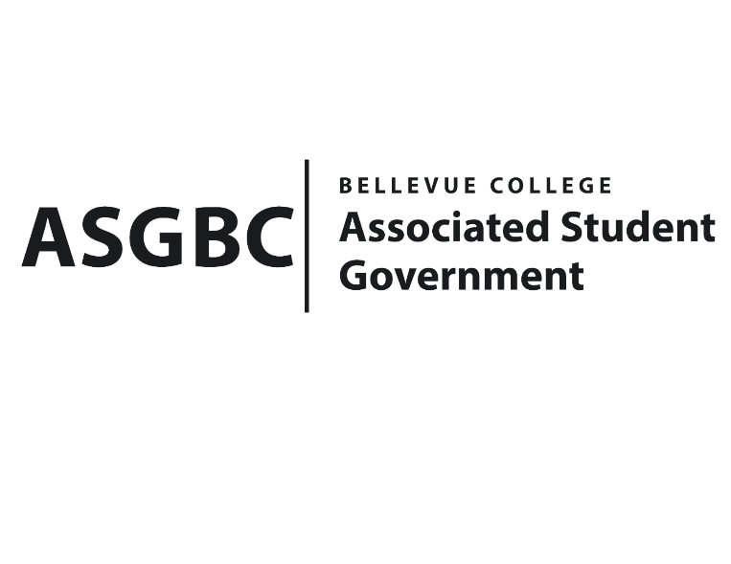
BOARD OF DIRECTORS
Session I
Date: May 10th, 2024
03-01-51

Submitted by Heidi Ngo Treasurer

BOARD BILL 03-01-51 - An Act to Approve Funding for the Possibilities Club’s Event in the amount of $500.

WHEREAS: The Bellevue College Possibilities Club plans to have food for their club meeting to promote interaction between members and help build friendships; and

WHEREAS: The Bellevue College Possibilities Club will support their missions and goals by aiming to promote members to find their own hobbies and make friends together.

THEREFORE, BE IT ENACTED BY THE ASSOCIATED STUDENT GOVERNMENT OF BELLEVUE COLLEGE BOARD OF DIRECTORS

THAT: The Associated Student Government of Bellevue College approves the allocation of $500.00 to fund the Bellevue College Possibilities Club’s funding request; and

THAT: The approved funding is allocated from the ASG General account; and,

THAT: A copy of this bill be forwarded to Heid Ngo, Treasurer and Hristo Stoynov, Office of Student Engagement Program Coordinator, Denise Johnson, The Bellevue Possibilities Club Advisor, Heija Jin, The Bellevue College Possibilities Club President.
End

I, Sean Behl, President of the Associated Student Government of Bellevue College, do herby certify that Board Bill 03-01-51 was duly approved by the Board of Directors on 03/10/2024. I attest to the accuracy and authenticity of the contents of this bill.



__________________________________
Sean Behl
ASG President

