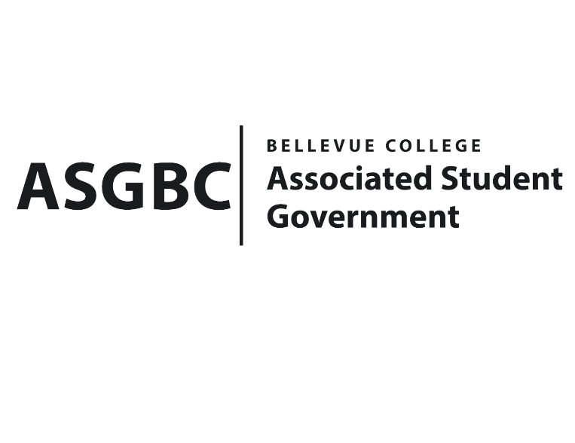
BOARD OF DIRECTORS
Session I
Date: May 10th, 2024
03-01-50

Submitted by Heidi Ngo Treasurer

BOARD BILL 03-01-50 - An Act to Approve Funding for the Hong Kong Student Association’s Weekly Food for Meetings in the amount of $959.47.

WHEREAS: The Bellevue College Hong Kong Student Association plans to have weekly meetings with food; and

WHEREAS: The Bellevue College Hong Kong Student Association’s event/activity directly supports the Hong Kong Student Association's vision by creating a vibrant celebrating Hong Kong culture. It fulfills the mission by promoting cultural exchange and education through traditional snacks and activities/games like mahjong and the aero plane chess.

THEREFORE, BE IT ENACTED BY THE ASSOCIATED STUDENT GOVERNMENT OF BELLEVUE COLLEGE BOARD OF DIRECTORS

THAT: The Associated Student Government of Bellevue College approves the allocation of $959.47 to fund the Bellevue College Hong Kong Student Association’s funding request; and

THAT: The approved funding is allocated from the ASG Cultural account; and,

THAT: A copy of this bill be forwarded to Heid Ngo, Treasurer and Hristo Stoynov, Office of Student Engagement Program Coordinator, Sophie Leung, The Bellevue Hong Kong Student Association Advisor, and Cheuk Lam Kam, The Bellevue College Hong Kong Student Association President.
End

I, Sean Behl, President of the Associated Student Government of Bellevue College, do herby certify that Board Bill 03-01-50 was duly approved by the Board of Directors on 03/10/2024. I attest to the accuracy and authenticity of the contents of this bill.



__________________________________
Sean Behl
ASG President

