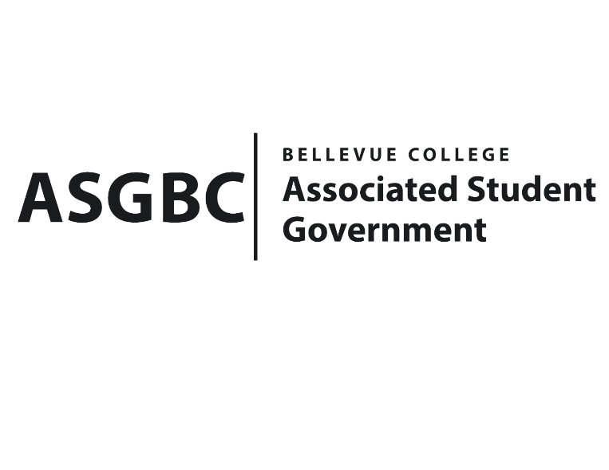
BOARD OF DIRECTORS
Session I
Date: May 31st, 2024
02-01-33

Submitted by Sean Behl, ASGBC President

BOARD BILL 02-01-33: An Act to Appoint Kiersten “Kiki” Moorman-Zierman to the ASGBC Student Senate as the Science Senator for the 2024-2025 Academic Year

WHEREAS: The ASGBC Board of Directors has appointed Kiersten “Kiki” Moorman-Zierman to serve as the Science Senator for the 2024-2025 academic year; and,

WHEREAS: The Board of Directors has full confidence in Kiersten “Kiki” Moorman-Zierman’s ability to excel as the Science Senator and contribute to the work of the ASGBC effectively; and,

WHEREAS: Kiersten “Kiki” Moorman-Zierman has met all of the requirements to serve in the ASGBC Student Senate for the 2024-2025 academic year; and,

WHEREAS: Kiersten “Kiki” Moorman-Zierman’s employment shall commence on September 1st, 2024 and conclude on June 30th, 2025.

THEREFORE, BE IT ENACTED BY THE ASSOCIATED STUDENT GOVERNMENT OF BELLEVUE COLLEGE BOARD OF DIRECTORS

THAT: The Associated Student Government of Bellevue College Board of Directors hereby ratifies the appointment of Kiersten “Kiki” Moorman-Zierman to the ASGBC Student Senate as the Science Senator for the 2024-2025 Academic Year,

THAT: A copy of this bill be forwarded to Kiersten “Kiki” Moorman-Zierman, 2024-2025 Science Senator; Daniel Ngoy, 2024-2025 ASGBC President; Daniella Salima, 2024-2025 ASGBC Vice President; Julie Nguyen, ASGBC Secretary; Amy McCrory, ASGBC Advisor; and Mike Kaptik, Dean of Student Life and Leadership/ASGBC Advisor.

End

I, Sean Behl, President of the Associated Student Government of Bellevue College, do herby certify that Board Bill 02-01-33 was duly approved by the Board of Directors on 06/07/2024. I attest to the accuracy and authenticity of the contents of this bill.

__________________________________
Sean Behl
ASG President

