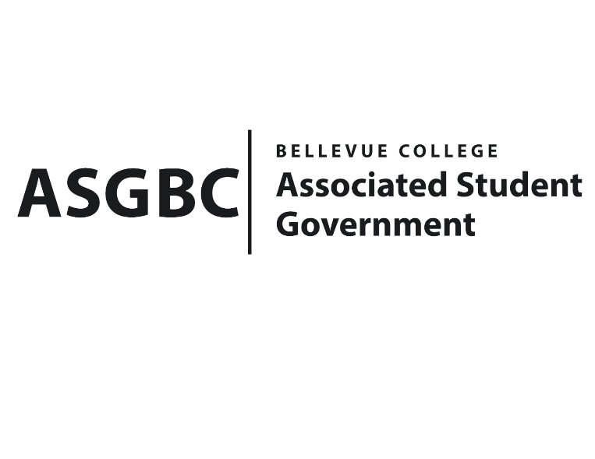
BOARD OF DIRECTORS
Session I
Date: June 14th, 2024
01-01-04

Submitted by Sean Behl, ASGBC President

BOARD BILL 01-01-04: An Act to Amend the ASGBC Bylaws
WHEREAS: The ASGBC Bylaws require several amendments to bring the document in line with the recent amendments to the ASGBC Constitution; and,

WHEREAS: Sean Behl presents several amendments to the ASGBC Bylaws that include rules for the offices and programs of the ASGBC; and,

WHEREAS: These amendments also include the addition of three new committees, the Voluntary Student Fee Oversight Committee, the Student Commencement Speaker Selection Committee, and the Student Exemplary Achievement and Nobility Award Selection Committee; and,

WHEREAS: These amendments are necessary for the effective and efficient operations of the ASGBC.

THEREFORE, BE IT ENACTED BY THE ASSOCIATED STUDENT GOVERNMENT OF BELLEVUE COLLEGE BOARD OF DIRECTORS

THAT: The Board of Directors hereby adopts the ASGBC Bylaws amendments as presented; and,

THAT: The ASGBC Secretary and ASGBC Emerging Technology Representative ensure that the amended document is archived and made public; and,

THAT: A copy of this bill be forwarded to all current ASGBC personnel; Mike Kaptik, ASGBC Advisor and Dean of Student Life and Leadership; Amy McCrory, ASGBC Advisor; and Bradely Huggins, Director of Student Engagement.

End
I, Sean Behl, President of the Associated Student Government of Bellevue College, do herby certify that Board Bill 01-01-04 was duly approved by the Board of Directors on 06/14/2024. I attest to the accuracy and authenticity of the contents of this bill.



__________________________________
Sean Behl
ASG President

