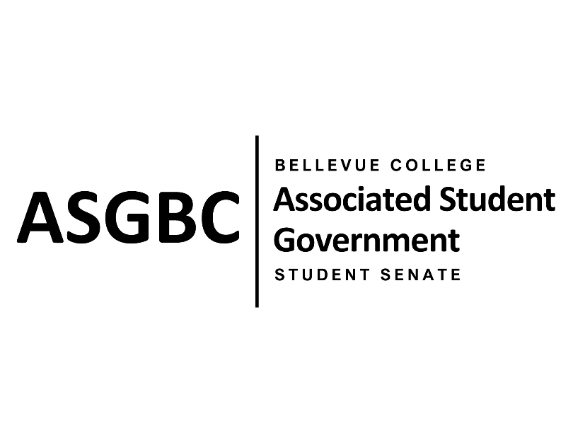

ASG Student Senate Meeting Minutes
March 5th, 2024 | N-201| 5:30-7
Next Meeting: March 12th, 2024

- CALL TO ORDER
  - Rebecca Mbaka calls the meeting to order at 5:35pm

- ROLL CALL
  - Speaker: Rebecca Mbaka (present)
  - Vice Speaker: Stephanie Nehema (absent, excused)
  - Clerk: Sienna Jarrard (present)
  - Arts and Humanities Senator: Katrina Gunvaldson (present)
  - Business and Technology: Zoe Mukaba (absent, excused)
  - Health Science, Education, and Wellness Institute: Cornelie Aloma (present)
  - Social Science: Adam Gong (present)
  - Science: Marita Bwalya (present)
  - Housing: Lucy Ju (absent, unexcused)
  - Athletics: Kes Smith (present)
  - Running Start: Mumina Guled (present)
  - International: Graciella Nzowo (tardy, unexcused)
  - At-Large: Merveil Kalala (present)
  - At-Large: Daniella Salima (present)
  - At-Large: Marie Lumiere Kawende (present)
  - At-Large: Emmanuel Ngoie (present)
  - At-Large: Vallon Bosango (present)

- INTRODUCTIONS
  - Sean Behl-ASG President
  - Amy McCrory- ASG and Senate Advisor
  - Julie Nguyen- ASG Secretary
  - Dan Nzowo

- APPROVAL OF AGENDA
  - Daniella Salima motions, Emmanuel Ngoie seconds, motion passes by (11-0-0)
- APPROVAL OF MINUTES
  - Marita Bwalya motions, Daniella Salima seconds, motion passes by (11-0-0)
- OPEN FORUM
  - Sienna Jarrard gave the Senate a recap on the open forum discussion with Ty Bergstrom during the March 1st Board of Directors meeting regarding food services.
- REPORTS
  - Speaker
    - The Speaker has been communicating with Mike Kaptik regarding the passed legislation and it being sent to the appropriate people.
- UNFINISHED BUSINESS
  - SENATE RESOLUTION SR-01-04: An Act to Extend the Main Cafeteria Open Hours
    - Emmanual Ngoie and Marie Lumiere Kawende present a resolution to address the operating hours of the C-Building (Main) Cafeteria and extend them beyond 2pm.
    - The resolution requests that the Bellevue College Food Services adjust staff and resources to support extending the open hours until 4pm.
    - Merveil Kalala motions to table the resolution indefinitely, Graciella Nzowo seconds, motion passes by (11-0-1)
  - SENATE RESOLUTION SR-01-05: Affordable Cafeteria Buffet Initiative
    - Emmanuel Ngoie and Merveil Kalala present a resolution to address the cost of food in the C-Building Cafeteria and the student feedback that the cost was leading to food insecurity.
    - The resolution requests that the Bellevue College Food Services add a buffet option for students with a cost per plate options and seek input from the student body regarding food.
    - Marie Lumiere Kawende motions to table the resolution indefinitely, Daniella Salima seconds, motion passes by (12-0-0)
- NEW BUSINESS
  - SENATE RESOLUTION SR-01-06: A Suggestion for a Constant and Regular Technical Maintenance Check Throughout the Campus
    - Marita Bwalya and Marie Lumiere Kawende present a resolution to suggest a more frequent technical maintenance check of the computers and printers on campus.
    - The resolution requests that the Bellevue College Technology Service Desk implement regular maintenance checks and provide a system to easily report and track technical issues.
    - Emmanuel Ngoie motions to refer the resolution to the Board of Directors for review, Daniella Salima seconds, motion passes by (10-1-1)
  - SENATE RESOLUTION SR-01-07: Improving Food Safety and Awareness at the Benefits Hub
    - Zoe Mukaba and Cornelie Aloma present a resolution to improve food safety and awareness at the Benefits Hub.
    - The resolution requests that the Benefits Hub administration follow established food expiration guidelines, monitor food expiration in the pantry and remove expired items.
    - The resolution also requests that Bellevue College commit to providing robust support and resources to ensure timely restocking, increase food options, and support minimizing the occurrence of expired food items.
    - Graciella Nzowo motions to refer the resolution to the Board of Directors for review, Daniella Salima seconds, motion passes by (12-0-0)
  - SENATE RESOLUTION SR-01-08: A Resolution to Promote a Higher Balance for Students’ Orca Cards
    - Vallon Bosango and Kes Smith present a resolution to promote a higher balance for student Orca cards.
    - The resolution requests that the Bellevue College transportation department allow students to purchase both an Orca Blue Card and Orca Silver card on a quarterly basis.
    - Graciella Nzowo motions to refer the resolution to the Board of Directors for review, Daniella Salima seconds, motion passes by (12-0-0)
- DISCUSSION ITEMS
  - Paper Usage for Senate Meetings
    - 9 Senate members have requested paper copies, the rest will use their computers to access meeting materials.
  - Board of Directors Concerns on Campus
    - Outdoor Lighting on Campus
    - U-Building Ballroom Cost for Student Usage
    - Student Access to 25Live & Team Dynamics
  - Reminder: Any Conflicts with a Spring Quarter Meeting Time of 5:30pm to 7pm on Tuesdays Must Be Communicated by March 12th.
  - Student Legal Services
    - Establishing a Student Legal Services to provide legal consultations and advice to students at Bellevue College.
    - Funding through a voluntary fee.
  - Committee Applications
    - Sienna Jarrard is looking for one Senator and one Student-at-Large for the Electoral Committee.
  - S&A Application
    - The S&A application is open until March 13th at 5pm.
- ANNOUNCEMENTS
  - Sienna Jarrard announces that the 2024-2025 Board of Directors application closes on March 31st.
  - Rebecca Mbaka announces that the 2024 Commencement Speaker application closes on March 5th.
  - Daniella Salima announces that the Pan African Women’s Day Celebration is on March 7th.
    - There is a panel from 11:30 to 1 in D106.
    - There is a celebration event from 4 to 7 in the Cafeteria.
  - Rebecca Mbaka announces that there will be a Senate and Board of Directors Team Bonding with games and activities on March 15th around 3pm.
- ADJOURNMENT
  - Daniella Salima motions, Marie Lumiere Kawende seconds, Rebecca Mbaka adjourns the meeting at 7:09pm.

