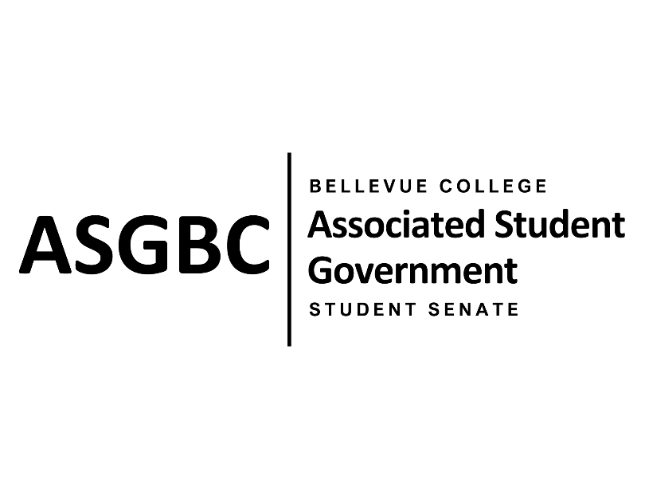

ASG Student Senate Meeting Agenda
April 23rd, 2024 | N-201| 5:30-7:00
Next Meeting: April 30th, 2024

- CALL TO ORDER
  - Stephanie Nehema calls the meeting to order at 5:34pm

- ROLL CALL
  - Speaker: Rebecca Mbaka (absent, excused)
  - Vice Speaker: Stephanie Nehema (present)
  - Clerk: Sienna Jarrard (present)
  - Arts and Humanities Senator: Katrina Gunvaldson (present)
  - Business and Technology: Zoe Mukaba (absent, excused)
  - Health Science, Education, and Wellness Institute: Cornelie Aloma (present)
  - Social Science: Adam Gong (present)
  - Science: Marita Bwalya (absent, excused)
  - Housing: Lucy Ju (absent, unexcused)
  - Athletics: Kes Smith (present)
  - Running Start: Mumina Guled (present)
  - International: Graciella Nzowo (present, tardy)
  - At-Large: Merveil Kalala (present)
  - At-Large: Daniella Salima (present)
  - At-Large: Marie Lumiere Kawende (present)
  - At-Large: Emmanuel Ngoie (present)
  - At-Large: Vallon Bosango (present)

- INTRODUCTIONS
  - Sean Behl- ASG President
  - Dan Nzowo- Student
  - Jay Nguyen- Student

- APPROVAL OF AGENDA
  - Daniella Salima motions, Emmanuel Ngoie seconds, motion passes by (11-0-0)
- APPROVAL OF MINUTES
  - Daniella Salima motions, Emmanuel Ngoie seconds, motion passes by (11-0-0)
- OPEN FORUM
  - No participants
- REPORTS
  - Speaker absent
- UNFINISHED BUSINESS
  - SENATE RESOLUTION SR-01-06: A Suggestion for a Constant and Regular Technical Maintenance Check Throughout Campus
    - Marita Bwalya and Marie Lumiere Kawende present a resolution to suggest a more frequent technical maintenance check of the computers and printers on campus.
    - The resolution requests that the Bellevue College Technology Service Desk implement regular maintenance checks and provide a system to easily report and track technical issues.
    - Emmanuel Ngoie motions to table to the next meeting, Daniella Salima seconds, motion passes by (11-0-0)
  - SENATE RESOLUTION SR-01-11: A Resolution to Suggest the Creation of a Student Life Canvas Course
    - Sienna Jarrard presents a resolution to suggest the creation of a specific “Student Life” Canvas course to inform all students of student life and campus information easily.
    - The resolution requests that Student Affairs collaborates with the ASGBC, Office of Student Engagement, and ITS to create this Canvas course.
    - Vallon Bosango motions to approve the resolution, Daniella Salima seconds, motion passes by (11-0-0)
  - SENATE RESOLUTION SR-01-12: A Resolution to Further Subsidize ORCA Cards and Increase Allocation Amounts
    - Sienna Jarrard presents a resolution to further subsidize ORCA cards and increase the distribution amounts on them.
    - The resolution requests that the Office of Sustainability collaborates with the ASGBC to secure further subsidization and increase the initial balance on ORCA cards.
    - Daniella Salima motions to approve the resolution , Marie Lumiere Kawende seconds, motion passes by (11-0-0)
  - SENATE BILL SB-01-01: A Recommendation to the Board of Directors to Enact Nominal Voluntary Fees to Ensure the Sustainability of the Services and Activities Fee Process
    - Sienna Jarrard presents a bill to recommend the Board of Directors to enact nominal voluntary fees.
    - The bill requests that the Associated Student Government of Bellevue College Board of Directors enact a voluntary fee to support the Academic Success Center, the ASGBC Office of Civic Engagement, and the membership dues of the Washington Student Association. It also recommends the establishment of a committee to oversee all voluntary student fees and to further work with the administration to find alternative sources of funding.
    - Daniella Salima motions to table the resolution to the next meeting, Cornelie Aloma seconds, motion passes by (10-0-1)
- NEW BUSINESS
  - SENATE RESOLUTION SR-01-13: A Resolution to Address Rental Costs and Hourly Minimums for Students on the 3rd Floor of the U-Building
    - Sienna Jarrard presents a resolution to address rental costs and hourly minimums for students to use rooms on the 3rd floor of the U-Building.
    - The resolution requests Bellevue College Eevnts and Facilities Rentals reconsider the pricing and 4-hour minimum for students to rent out the spaces.
    - Vallon Bosango motions, Emmanuel Ngoie seconds, motion passes by (11-0-0)
- DISCUSSION ITEMS
  - Discussion Item
    - Quarterly Reports
      - Quarterly reports were due on April 16th, please email them to Sienna Jarrard and Rebecca Mbaka as soon as possible.
    - Senate Participation
      - The Senate Leadership is encouraging all Senators to participate more in meetings and write more resolutions.
    - Discussion Items
      - The Senate Leadership is encouraging Senators to utilize the discussion items during meetings.
    - Payment for Legislation
      - Senators are paid 1 hour per piece of legislation written during Winter and Spring Quarter.
    - Tardiness
      - The Senate Leadership reminds all Senators to please be on time to meetings.
- ANNOUNCEMENTS
  - Sienna Jarrard announces that the next ASGBC Election Event will be on April 30th at 1pm in the Cafeteria, and voting for the 2024-25 President and Vice President will be open from May 6th to May 9th.
- ADJOURNMENT
  - Daniella Salima motions, Merveil Kalala seconds, motion passes by (9-2-0), Stephanie Nehema adjourns the meeting at 6:28pm.

