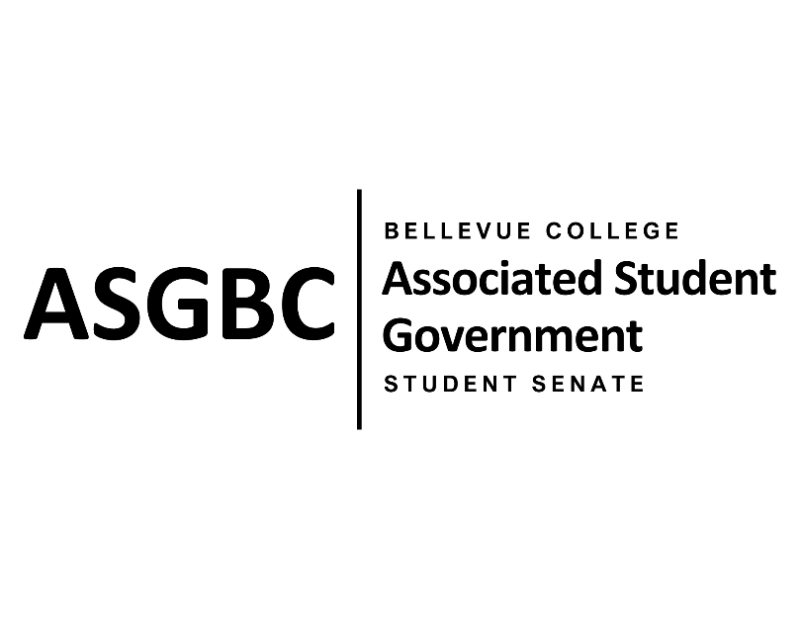

ASG Student Senate Meeting Agenda
April 16th, 2024 | N-201| 5:30-7
Next Meeting: April 23rd, 2024

- CALL TO ORDER
  - Rebecca Mbaka calls the meeting to order at 5:39pm.

- ROLL CALL
  - Speaker: Rebecca Mbaka (present)
  - Vice Speaker: Stephanie Nehema (present)
  - Clerk: Sienna Jarrard (present)
  - Arts and Humanities Senator: Katrina Gunvaldson (present, tardy)
  - Business and Technology: Zoe Mukaba (present)
  - Health Science, Education, and Wellness Institute: Cornelie Aloma (present)
  - Social Science: Adam Gong (present)
  - Science: Marita Bwalya (present)
  - Housing: Lucy Ju (absent, unexcused)
  - Athletics: Kes Smith (present)
  - Running Start: Mumina Guled (present)
  - International: Graciella Nzowo (present)
  - At-Large: Merveil Kalala (present)
  - At-Large: Daniella Salima (present)
  - At-Large: Marie Lumiere Kawende (present)
  - At-Large: Emmanuel Ngoie (present)
  - At-Large: Vallon Bosango (present)

- INTRODUCTIONS
  - Sean Behl- ASG President
  - Amy McCrory- ASG and Student Senate Advisor
  - Dan Nzowo- Student

- APPROVAL OF AGENDA
  - Vallon Bosango motions, Emmanuel Ngoie seconds, motion passes by (12-0-0)
- APPROVAL OF MINUTES
  - Marita Bwalya motions, Marie Lumiere Kawende seconds, motion passes by (12-0-0)
- OPEN FORUM
  - No participants
- REPORTS
  - Rebecca Mbaka has been encouraging collaboration, writing more resolutions in the Senate, and working on getting Senators in classrooms.
- UNFINISHED BUSINESS
  - SENATE RESOLUTION SR-01-06: A Suggestion for a Constant and Regular Technical Maintenance Check Throughout Campus
    - Marita Bwalya and Marie Lumiere Kawende present a resolution to suggest a more frequent technical maintenance check of the computers and printers on campus.
    - The resolution requests that the Bellevue College Technology Service Desk implement regular maintenance checks and provide a system to easily report and track technical issues.
    - Vallon Bosango motions to table to the next meeting, Daniella Salima seconds, motion passes by (12-0-0)
- NEW BUSINESS
  - SENATE RESOLUTION SR-01-10: A Resolution to Improve the Students’ Life Experience by Installing a Bottleless Multi-Temperature Water Fountain in the C-Building Second Floor
    - Vallon Bosango presents a resolution to install a bottleless multi-temperature water fountain in the C-Building to provide students with warm and cold water.
    - The resolution requests that the Student Environmental Sustainability Fund purchase this water fountain.
    - Daniella Salima motions to table the resolution indefinitely, Marita Bwalya seconds, motion passes by (13-0-0)
  - SENATE RESOLUTION SR-01-11: A Resolution to Suggest the Creation of a Student Life Canvas Course
    - Sienna Jarrard presents a resolution to suggest the creation of a specific “Student Life” Canvas course to inform all students of student life and campus information easily.
    - The resolution requests that Student Affairs collaborates with the ASGBC, Office of Student Engagement, and ITS to create this Canvas course.
    - Vallon Bosango motions to refer the resolution to the Board of Directors, Daniella Salima seconds, motion passes by (13-0-0)
  - SENATE RESOLUTION SR-01-12: A Resolution to Further Subsidize ORCA Cards and Increase Allocation Amounts
    - Sienna Jarrard presents a resolution to further subsidize ORCA cards and increase the distribution amounts on them.
    - The resolution requests that the Office of Sustainability collaborates with the ASGBC to secure further subsidization and increase the initial balance on ORCA cards.
    - Vallon Bosango motions to refer the resolution to the Board of Directors, Marie Lumiere Kawende seconds, motion passes by (13-0-0)
  - SENATE BILL SB-01-01: A Recommendation to the Board of Directors to Enact Nominal Voluntary Fees to Ensure the Sustainability of the Services and Activities Fee Process
    - Sienna Jarrard presents a bill to recommend the Board of Directors to enact nominal voluntary fees.
    - The bill requests that the Associated Student Government of Bellevue College Board of Directors enact a voluntary fee to support the Academic Success Center, the ASGBC Office of Civic Engagement, and the membership dues of the Washington Student Association. It also recommends the establishment of a committee to oversee all voluntary student fees and to further work with the administration to find alternative sources of funding.
    - Vallon Bosango motions, Marita Bwalya seconds, motion passes by (13-0-0)
- DISCUSSION ITEMS
  - Discussion Item
    - Quarterly Reports
      - Quarterly reports are due on April 16th at 11:59pm and must be emailed to Sienna Jarrard and Rebecca Mbaka.
    - Resolution Updates
      - Dr. May is formulating responses to some of the resolutions.
      - The Benefits Hub has been noticeably more active on Instagram, posting about restocks to the Food Pantry.
      - Bellevue College will be repairing roads around campus this summer.
- ANNOUNCEMENTS
  - Sienna Jarrard announces that the ASGBC is currently hiring for the 2024-25 Student Senate, Office of Civic Engagement, and Office of Events and Community Relations.
  - Sienna Jarrard announces that the ASGBC Elections are currently going on and events will be held on April 23rd and 30th from 1-2:30pm in the Cafeteria for students to learn more about their Presidential and Vice-Presidential candidates.
- ADJOURNMENT
  - Daniella Salima motions, Marita Bwalya seconds, motion passes by (13-0-0), Rebecca Mbaka adjourns at 6:14pm.

