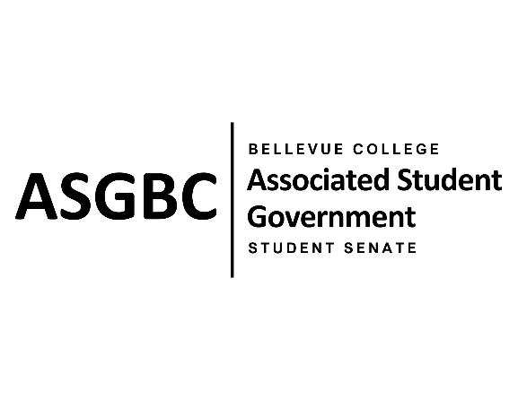
STUDENT SENATE
Session I
Date: April 23, 2024
SR-01-13

Submitted by Sienna Jarrard, Student Senate Clerk
Sponsored by Marita Bwalya, Emmanuel Ngoie, Marie Lumiere Kawende

SENATE RESOLUTION SR-01-13: A Resolution to Address Rental Costs and Hourly Minimums for Students on the 3rd Floor of the U-Building

WHEREAS: Students can book rooms throughout campus for events or meetings for no cost and with no hourly minimum except for U301AB, U312, and U313; and,

WHEREAS: Students are required to pay $325-$650 for usage of the Gary F. Locke Ballroom and must rent it for a minimum for 4 hours, same as outside organizations; and,

WHEREAS: Bellevue College has limited venues that can accommodate hundreds of students for large events forcing students to utilize the U-Building venues and incur hundreds of dollars in costs.

THEREFORE, BE IT RESOLVED BY THE ASSOCIATED STUDENT GOVERNMENT OF BELLEVUE COLLEGE

THAT: The Bellevue College Events and Facilities Rentals reconsider prices for students to rent out the spaces and offer them at lower or no cost to students; and,

THAT: The Bellevue College Events and Facilities Rentals reconsider the minimum hour amount for students as many students are not hosting 4-hour long events; and,

THAT: A copy of this legislation be sent to the Executive Director of Finance and the VP of Admin Services.

End
________________________________ |  | __________________________________
Sean Behl  ASG President |  | Rebecca Mbaka  Speaker of the Senate

