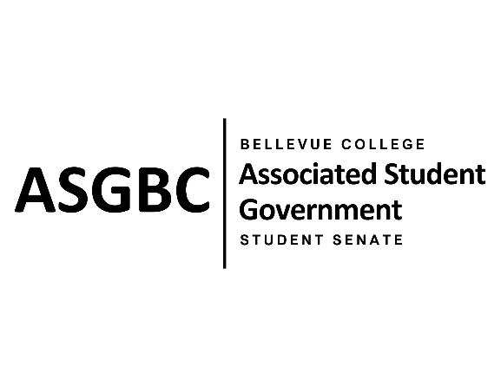
STUDENT SENATE
Session I
Date: April 26th, 2024
SR-01-12

Submitted by Sienna Jarrard; at the request of Sean Behl, ASG President
Sponsored by Vallon Bosango

SENATE RESOLUTION SR-01-12: A Resolution to Further Subsidize ORCA Cards and Increase Initial Distribution Amounts.

WHEREAS: Many students at Bellevue College rely on public transportation to commute to-and-from campus on a daily basis; and,

WHEREAS: Students have often reported an insufficient initial balance on their ORCA card resulting in the inability to use public transportation at the reduced rate later in the quarter; and,

WHEREAS: Students would benefit from the further subsidization of ORCA cards.

THEREFORE, BE IT RESOLVED BY THE ASSOCIATED STUDENT GOVERNMENT OF BELLEVUE COLLEGE

THAT: The Office of Sustainability collaborates with the ASGBC to secure the further subsidization of ORCA passes; and,

THAT: The Office of Sustainability collaborates with the ASGBC to secure the increase of the initial balance of ORCA passes; and,

THAT: A copy of this resolution is sent to Sara Holzknecht, Director of Sustainability; Elissa Gordon, Associate Director of Sustainability; Julie Nguyen, ASG Secretary; and Mike Kaptik, Dean of Student Life and Leadership.

End
________________________________ |  | __________________________________
Sean Behl  ASG President |  | Rebecca Mbaka  Speaker of the Senate

