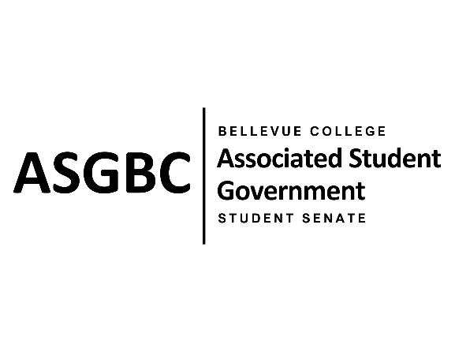
STUDENT SENATE
Session I
Date: March 5th, 2024
SR-01-07

Submitted by Zoe Mukaba, Cornelie Aloma
Sponsored by Daniella Salima, Emmanuel Ngoie, Marie-Lumiere Kawende, Marita Bwalya,

SENATE RESOLUTION SR-01-07: Improving Food Safety and Awareness at the Benefits Hub

WHEREAS: Bellevue College operates a program known as the Benefits Hub, aimed at assisting students with financial challenges, food insecurity, and other issues affecting their study-work-life balance, and maintains a food pantry in the U building where free food and supplies are provided to students in need; and,

WHEREAS: Despite the establishment of food expiration guidelines by the Benefits Hub, which require the purchase of products before their specified expiration dates and the disposal of pantry items three days past their label date or after one month in the pantry to ensure the quality and safety of supplies provided to students, occasional instances of expired food items are found at the Benefits Hub food pantry, potentially impacting the quality and safety of supplies provided to students; and,

WHEREAS: The lack of awareness among students about restocking schedules contributes to food staying at the pantry for extended periods and expiring, as students may have difficulty remembering restock times due to busy schedules.

THEREFORE, BE IT RESOLVED BY THE ASSOCIATED STUDENT GOVERNMENT OF BELLEVUE COLLEGE

THAT: The Benefits Hub administration is urged to strictly follow the established food expiration guidelines, including implemented measures to regularly monitor and remove expired food items from its inventory to maintain the quality and safety of supplies provided to students; and,

THAT: Bellevue College commits to providing robust support and resources to the Benefits Hub, ensuring timely restocking of the pantry with fresh and diverse food supplies, thereby prioritizing adequate resourcing and support to minimize the occurrence of expired food items, enhance the quality and safety of supplies provided to students, and increase the availability of food options to meet student needs; and,

THAT: The Benefits Hub administration is encouraged to enhance efforts to raise awareness among students about restocking schedules through regular announcements on their website or texts messages for students enrolled in their messaging system, to help students stay informed and up to date on available resources; and,

THAT: A copy of this resolution be sent to Ranulfo Molina, Associate Director of the Benefits Hub; Kari Hammond, Director of Workforce Education & Benefits Hub; Megan Kaptik, Dean of Student Support; and Judith Hernandez Chapar, Interim Associate Vice President of Student Affair.

End
________________________________ |  | __________________________________
Sean Behl  ASG President |  | Rebecca Mbaka  Speaker of the Senate

