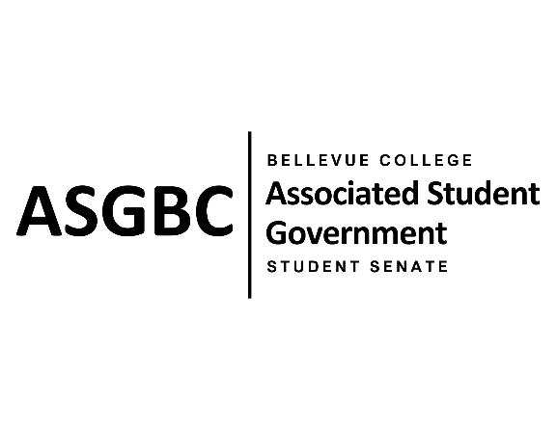
STUDENT SENATE
Session I
Date: April 16th, 2024
SB-01-01

Submitted by Sienna Jarrard; at the request of Sean Behl, ASG President
Sponsored by Stephanie Nehema, Marita Bwalya,

SENATE BILL SB-01-01: A Recommendation to the Board of Directors to Enact Nominal Voluntary Student Fees to Ensure the Sustainability of the Services and Activities Fee Process

WHEREAS: Services and Activities Fees only generate approximately 2.7 - 3.0 million dollars each academic year; and,

WHEREAS: Combined the Associated Student Government of Bellevue College, the Office of Student Engagement, and the Academic Success Center request approximately 2.7 million dollars each academic year; and,

WHEREAS: Currently most requests submitted through the Services and Activities Fee process are able to be funded because of the amount of rollover we have each year, but the rollover generated each year is expected to decrease going forward; and,

WHEREAS: The enactment of nominal student fees will ensure the sustainability of the services and activities fee process for the foreseeable future.

THEREFORE, BE IT ENACTED BY THE ASSOCIATED STUDENT GOVERNMENT OF BELLEVUE COLLEGE STUDENT SENATE

THAT: The Associated Student Government of Bellevue College Board of Directors enact a voluntary student fee to support the ASGBC Office of Civic Engagement and the membership dues of the Washington Student Association; and,

THAT: The Associated Student Government of Bellevue College Board of Directors establish a committee to oversee the collection and distribution of all voluntary student fees, to ensure that student funds are being utilized properly and that students are not being over charged; and,

THAT: The Associated Student Government of Bellevue College Board of Directors works with the administration to find alternative sources of funding for current services, programs and offices funded through the Services and Activities Fee process; and,

THAT: A copy of this bill be sent to the Associated Student Government of Bellevue College Board of Directors; Julie Nguyen, ASG Secretary; Amy McCrory, ASG Advisor; and Mike Kaptik, Dean of Student Life and Leadership/ASG Advisor.

End
________________________________ |  | __________________________________
Sean Behl  ASG President |  | Rebecca Mbaka  Speaker of the Senate

