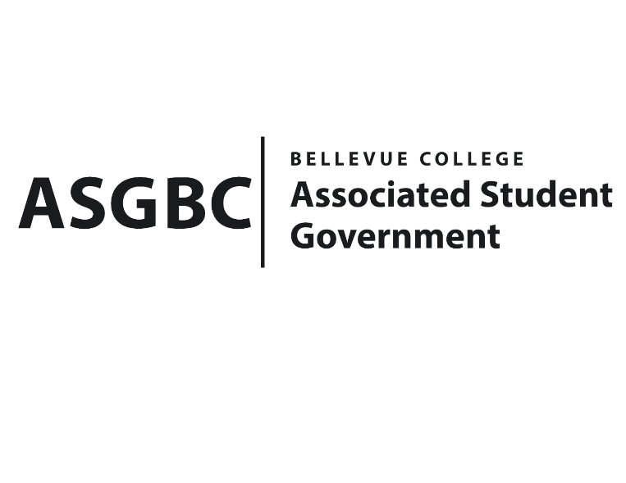
BOARD OF DIRECTORS
Session I
Date: May 3rd, 2024
04-01-48

Submitted by Stephanie Nehema, Social Responsibility Representative

BOARD BILL 04-01-48: An Act to Approve the SESF Committee Recommendation to Approve the Natural and Cultural History of the Upper Skagit Valley (Diablo Lake Tour) in the amount of $2,184

WHEREAS: Twenty students and two staff trip advisors will take a three-hour guided tour and boat ride on Diablo Lake, North Cascades, to discover the natural and cultural history of this comparatively untouched and infrequently visited region of our state; and,

WHEREAS: The tour will provide students with the chance to interact with environmental issues that are important both locally ang globally, such as salmon habitat, flood control, toxic mine effluent, large carnivore reintroduction, and the cultural heritage of the indigenous peoples of the area, offering insights about colonization, suppression, assimilation and modern-day manifestations of these policies and practices; and,

WHEREAS: Participating students will be encouraged to reflect on their observations and takeaways through a one-page written reflection, with media materials collected for further dissemination by the Office of Sustainability and Student Engagement; and,

WHEREAS: The responses and involvement of students will provide valuable insights that will guide the planning of future events that support social justice and environmental sustainability; and,

WHERAS: The Diablo Tour request was reviewed and approved by the SESF Committee on April 29th, 2024, with a vote in favor of allocating $2,184.

THEREFORE, BE IT ENACTED BY THE ASSOCIATED STUDENT GOVERNMENT OF BELLEVUE COLLEGE BOARD OF DIRECTORS

THAT: The funding request of $2,184 for the Natural and Cultural History of the Upper Skagit Valley (Diablo Lake Tour) be approved by the Board of Directors to cover the costs associated with the guided tour and boat ride.

THAT: A copy of this bill be forwarded to Sara Holzknecht, Director of Sustainability; Elissa Gordon, Associate Director of Sustainability; Hristo Stoynov, Students Engagement Program Manager; Julie Nguyen, ASG Secretary; and Stephanie Nehema, ASG Social Responsibility Representative.

End
I, Sean Behl, President of the Associated Student Government of Bellevue College, do hereby certify that Board Bill 04-01-48 was duly approved by the Board of Directors on 05/03/2024. I attest to the accuracy and authenticity of the contents of this bill.



__________________________________
Sean Behl
ASG President

