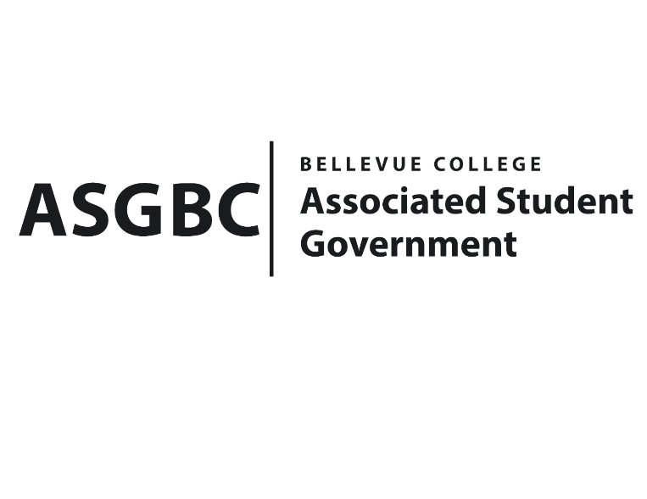
BOARD OF DIRECTORS
Session I
Date: May 3rd, 2024
04-01-46

Submitted by Stephanie Nehema, Social Responsibility Representative

BOARD BILL 04-01-46: An Act to Approve the SESF Committee Recommendation to Approve the 2024 BC CSA Pilot Program Extension in the amount of $5,350

WHEREAS: The 2024 BC CSA Pilot Program has been instrumental in providing the campus community with access to affordable, locally sourced organic fresh fruits and vegetables; and,

WHEREAS: The Sustainability Office's past initiatives, including the CSA offerings during Earth Week, the Fall Sustainability Series, and the ongoing pilot program, have demonstrated a strong demand for increased access to healthy food options on campus; and,

WHEREAS: The proposed funding of $5,350 will support the continuation of the CSA program through November 2024, ensuring that participants can continue to enjoy a monthly supply of approximately 10 different local organic fruits and vegetables at a subsidized cost of $20 per box; and,

WHERAS: The BC CSA Pilot Program Extension was reviewed and approved by the SESF Committee on April 29th, 2024, with a vote in favor of allocating $5,350.

THEREFORE, BE IT ENACTED BY THE ASSOCIATED STUDENT GOVERNMENT OF BELLEVUE COLLEGE BOARD OF DIRECTORS

THAT: The BC CSA Pilot Program be hereby ratified by the Board of Directors; and,

THAT: A copy of this bill be forwarded to Sara Holzknecht, Director of Sustainability; Elissa Gordon, Associate Director of Sustainability; Julie Nguyen, ASG Secretary; and Stephanie Nehema, ASG Social Responsibility Representative.

End
I, Sean Behl, President of the Associated Student Government of Bellevue College, do hereby certify that Board Bill 04-01-46 was duly approved by the Board of Directors on 05/03/2024. I attest to the accuracy and authenticity of the contents of this bill.



__________________________________
Sean Behl
ASG President

