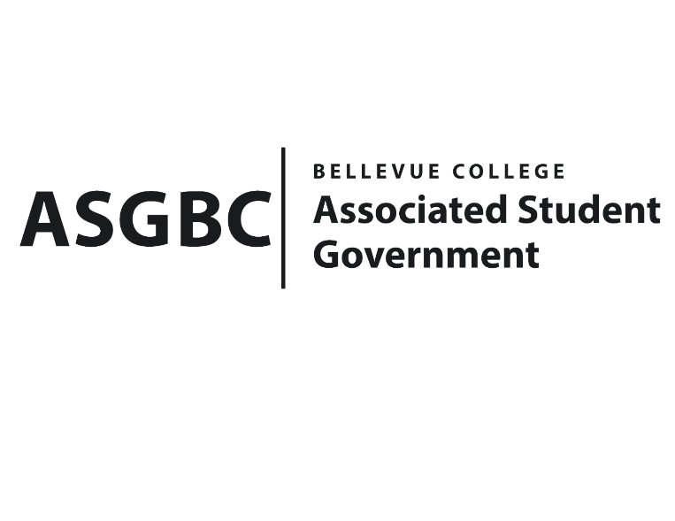
ASG Board of Directors Meeting Minutes
May 24th, 2024 | B-201 | 12:30-1:30
Next Meeting: May 31st, 2024

- CALL TO ORDER
  - Chair Sean Behl calls the meeting to order at 12:31

- ROLL CALL
  - President: Sean Behl (present)
  - Vice President: Rebecca Mbaka (absent, excused)
  - Executive Justice: Daniel Ngoy (present)
  - Treasurer: Heidi Ngo (absent, excused)
  - Secretary: Julie Nguyen (present)
  - Public Relations Rep: Joyce Diakubama (present)
  - Events Rep: Sienna Jarrard (present)
  - Social Responsibility Rep: Stephanie Nehema (present)
  - Emerging Technology Rep: Isadora Silva (present)

- INTRODUCTIONS
  - Michael Kaptik – Dean of Student Life / ASG Co-Advisor
  - Habiba Elswify – President of Bellevue College AI & Ethics Club
  - Zeba Khan – Treasurer of Bellevue College AI & Ethics Club
  - Dawud Rashid - Treasurer of Bellevue College Student for Justice Club
  - Alejandro Chavez – Event Coordinator of Bellevue College Student for Justice Club
  - Yousra Esseddiqi – President of Bellevue College Student for Justice Club
  - Kris Dessin - President of Bellevue College Stage Fright Drama Club
  - Max Shaw – Vice President of Bellevue College Stage Fright Drama Club
  - Ray Chung – Officer of Bellevue College Taiwanese Student Association
  - Mohammad Hussaini - Officer of Bellevue College Fitness Club
  - Aizada Gopyrova - Vice President of Bellevue College United Nations Association
- APPROVAL OF AGENDA
  - Sienna Jarrard motions, Daniel Ngoy seconds, motion passes by 7-0-0
- APPROVAL OF MINUTES
  - Joyce Diakubama motions, Stephanie Nehema seconds, motion passes by 7-0-0
- OPEN FORUM
  - Taiwanese Student Association Fundraising Event Recap
- REPORTS
  - President
    - The President has been working on finalizing the Board, the Office, and the Senate for next year.
    - The President has also been working on transitioning documents and training for next year's team.
    - The President has also been working on reviewing the Governance Documents, amending the Bylaws, and finalizing them for next year's team.
    - The President has also been working with ASG Events Rep. Sienna Jarrard on planning for the upcoming annual ASG Gala.
  - Vice President
    - The Vice President has been…
  - Executive Justice
    - The Executive Justice has been conducting interviews with other team members for the Senate next academic year.
  - Treasurer
    - The Treasurer has been…
  - Secretary
    - The Secretary has been working on preparing Agendas and Minutes for the Board of Directors meeting.
    - The Secretary has also been working on finalizing the Board of Directors for the 2024-2025 academic year.
  - Public Relations Rep.
    - The Public Relations Rep. has been working with citation committee regarding to the parking citations.
    - The Public Relations Rep. has also been working on advertising for ASGBC Gala, which will be on June 6th, 5-10pm
    - The Public Relations Rep. has also been working on finalizing the Board of Directors for the 2024-2025 academic year.
  - Events Rep.
    - The Events Rep. has been working on planning for the Gala, which will be on June 6th, RSVP is now open.
    - The Events Rep. has also been working on Nominations Awards, encouraging everyone to nominate, and this will be opened until next week.
    - The Events Rep. has also been working on hiring process for the Senate.
    - The Events Rep. has also been working on advertising Cap & Gown program, which will allow students to loan Cap & Gown for graduation instead of buying them as a more affordable option.
  - Social Responsibility Rep.
    - The Social Responsibility Rep. has been working on finalizing the Board of Directors for the 2024-2025 academic year.
    - The Social Responsibility Rep. has also been working with SESF Committee.
    - The Social Responsibility Rep. has also been working on hiring process for the Senate for the 2024-2025 academic year.
    - The Social Responsibility Rep. has also been working on advertising for ASGBC Gala, which will be on June 6th, 5-10pm
    - The Social Responsibility Rep. has also been working on some transition for the Board of Directors next year.
  - Emerging Technology Rep.
    - The Emerging Technology Rep. has been working on keeping ASG website updated.
    - The Emerging Technology Rep. has also been working on planning for the 2nd STF meeting, which will be on next Friday at 10am.
- UNFINISHED BUSINESS
- NEW BUSINESS
  - BOARD BILL 03-01-56 - An Act to Approve Funding for the Student for Justice Club’s Guest Speaker Event in the amount of $3,500.00
- Funds requested will be used to cover supplies/materials, food/beverages expenses for the Guest Speaker event, which will be on June 12th, estimated for 150-200 attendees.
- Joyce Diakubama motions, Sienna Jarrard seconds, the funding requested is passes by 7-0-0
  - BOARD BILL 03-01-57 - An Act to Approve Funding for the Fitness Club’s First Spring Quarter Event in the amount of $1,311.00
- Funds requested will be used to cover posters, performer cost, and food/beverage expense for the Event.
- The event is expected to take place in May (TBD the exact date), for about 40 students.
- Sienna Jarrard motions, Daniel Ngoy seconds, the funding requested is passes by 7-0-0
  - BOARD BILL 03-01-58 - An Act to Approve Funding for the Accounting Student Association’s Graduation Celebration in the amount of $1,730.00
- Funds requested will be used to cover printing cost, supplies/materials, food/beverages, and T-shirt expenses for the graduation celebration.
- The event is planned to be on June 12th, estimated for 50 people.
- Stephanie Nehema motions, Joyce Diakubama seconds, the funding requested is passes by 7-0-0
  - BOARD BILL 03-01-59 - An Act to Approve Funding for the AI & Ethics Club’s Hiya tour & AI panel in the amount of $700.00
- Funds requested will be used to cover food/beverages expense for the event, which will be on May 30th, estimated for about 30 attendees.
- The event will be off-campus, and it will be on Colombia Tower, Seattle
- Daniel Ngoy motions, Sienna Jarrard seconds, the funding requested is passes by 7-0-0
  - BOARD BILL 03-01-60 - An Act to Approve Funding for the Model United Nations Organization’s National Conference in Washington DC in the amount of $12,362.16
- Funds requested will be used to cover hotel, transportation, conference fees, food/beverages, and miscellaneous expenses for 2 days conference in Washington DC.
- The Conference will be on November 8-10, for 6 attendees.
- Sienna Jarrard motions, Joyce Diakubama seconds, the funding requested is passes by 7-0-0
  - BOARD BILL 03-01-62 - An Act to Approve Funding for the Stage Fright Drama Club’s Event in the amount of $1,310.66
- Funds requested will be used to cover supplies/materials costs for the One Act: Double Feature event, which will be on June 7th and June 8th, estimated for 30 attendees.
- Sienna Jarrard motions to amend the amount to $695.00, Julie Nguyen seconds, motion passes by 7-0-0
- Sienna Jarrard motions to approve the amended request, Joyce Diakubama seconds, the new funding request passes by 7-0-0
  - BOARD BILL 02-01-21 - An Act to Appoint Alarick Alfredo-Sorto to the ASGBC Board of Directors as the Chief of Administration for the 2024-2025 Academic Year
- Sienna Jarrard motions, Joyce Diakubama seconds, motion passes by 7-0-0
  - BOARD BILL 02-01-22 - An Act to Appoint Desiree Besson to the ASGBC Board of Directors as the Director of Finance for the 2024-2025 Academic Year
- Joyce Diakubama motions, Sienna Jarrard seconds, motion passes by 7-0-0
  - BOARD BILL 02-01-23 - An Act to Appoint Monica Yu to the ASGBC Board of Directors as the Director of Sustainability and Civic Engagement for the 2024-2025 Academic Year
- Sienna Jarrard motions, Joyce Diakubama seconds, motion passes by 7-0-0
  - BOARD BILL 02-01-24 - An Act to Appoint Kaden Yip to the ASGBC Board of Directors as the Director of Events and Programs for the 2024-2025 Academic Year
- Sienna Jarrard motions, Joyce Diakubama seconds, motion passes by 7-0-0
  - BOARD BILL 02-01-25 - An Act to Appoint Shanna Chua to the ASGBC Board of Directors as the Director of Public Relations for the 2024-2025 Academic Year
- Sienna Jarrard motions, Joyce Diakubama seconds, motion passes by 7-0-0
  - BOARD BILL 02-01-26- An Act to Appoint Florian Kabayo to the ASGBC Board of Directors as the Internal Affairs Director for the 2024-2025 Academic Year
- Joyce Diakubama motions, Sienna Jarrard seconds, motion passes by 7-0-0
  - BOARD BILL 02-01-27 - An Act to Appoint Merveil Kalala to the ASGBC Board of Directors as the External Affairs Director for the 2024-2025 Academic Year
- Sienna Jarrard motions, Joyce Diakubama seconds, motion passes by 7-0-0
  - BOARD BILL 02-01-28 - An Act to Appoint Dan Nzowo to the ASGBC Office of Events and Community Relations as the Events Coordinator for the 2024-2025 Academic Year
- Sienna Jarrard motions, Joyce Diakubama seconds, motion passes by 7-0-0
  - BOARD BILL 02-01-29 - An Act to Appoint Hansen Fan to the ASGBC Office of Events and Community Relations as the Community Relations Coordinator for the 2024-2025 Academic Year
- Joyce Diakubama motions, Sienna Jarrard seconds, motion passes by 7-0-0
  - BOARD BILL 02-01-30 - An Act to Appoint Emmanuel Ngoie to the ASGBC Office of Civic Engagement as the Policy Coordinator for the 2024-2025 Academic Year
- Joyce Diakubama motions, Sienna Jarrard seconds, motion passes by 6-0-0
  - BOARD BILL 02-01-31 - An Act to Appoint Khushi Chadha to the ASGBC Office of Civic Engagement as the Community Engagement Coordinator for the 2024-2025 Academic Year
- Sienna Jarrard motions, Joyce Diakubama seconds, motion passes by 6-0-0
  - BOARD BILL 04-01-45 - An Act to Establish the ASGBC Office of Events and Community Relations
- Sienna Jarrard motions, Joyce Diakubama seconds, motion passes by 6-0-0
  - BOARD BILL 04-01-46 - An Act to Establish the ASGBC Office of Civic Engagement
- Sienna Jarrard motions, Joyce Diakubama seconds, motion passes by 5-0-1
  - BOARD BILL 04-01-47: An Act to Approve the Charter of the Bellevue College Infosec Club.
- Joyce Diakubama motions, Julie Nguyen seconds, motion passes by 5-0-1
- DISCUSSION ITEMS
- ANNOUNCEMENTS
  - Sienna Jarrard announces the upcoming annual ASG Gala event, Jun 6th, 5-10pm
  - Sienna Jarrard announces the Nominations Awards is live, encouraging everyone to participate in.
  - Stephanie Nehema announces the upcoming SESF meeting, which will be on Tuesday Jun 4th.
- ADJOURNMENT
  - Sienna Jarrard motions, Joyce Diakubama seconds, the meeting is adjourned at 1:32

