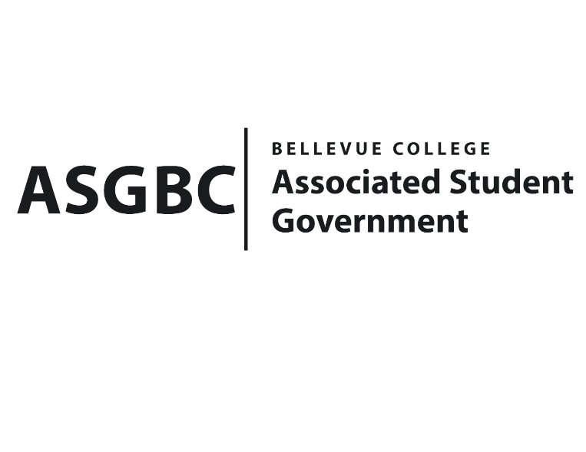
ASG Board of Directors Meeting Minutes
May 10th, 2024 | B-201 | 12:30-1:30
Next Meeting: May 17th, 2024

- CALL TO ORDER
  - Chair Sean Behl calls the meeting to order at 12:30

- ROLL CALL
  - President: Sean Behl (present)
  - Vice President: Rebecca Mbaka (present)
  - Executive Justice: Daniel Ngoy (present)
  - Treasurer: Heidi Ngo (present)
  - Secretary: Julie Nguyen (present)
  - Public Relations Rep: Joyce Diakubama (present)
  - Events Rep: Sienna Jarrard (present)
  - Social Responsibility Rep: Stephanie Nehema (absent, excused)
  - Emerging Technology Rep: Isadora Silva (absent, unexcused)

- INTRODUCTIONS
  - Michael Kaptik – Dean of Student Life / ASG Co-Advisor
  - Ray Chang – Treasurer of Bellevue College Taiwanese Student Association
  - Heija Jin – President of Bellevue College Possibilities Club
  - Max Shaw – Vice President of Bellevue College Stage Fright Club
  - Blake Dewitt – Secretary of Bellevue College Stage Fright Club
  - Ashton Gibson - Treasurer of Bellevue College Tech Startup Club
  - Joshua Monsalvatge – Vice President of Bellevue College Tech Startup Club
  - Justin Liao – President of Bellevue College Tech Startup Club
- APPROVAL OF AGENDA
  - Sienna Jarrard motions, Julie Nguyen seconds, motion passes by 7-0-0
- APPROVAL OF MINUTES
  - Sienna Jarrard motions, Julie Nguyen seconds, motion passes by 7-0-0
- OPEN FORUM
  - There were no Board members interested in participating in open forum.
- REPORTS
  - President
    - The President has been the hiring process, election for the Board next year.
    - The President has also been working on WSA legislation Assembly.
  - Vice President
    - The Vice President has been planning and running weekly Senate meeting.
    - The Vice President has also been volunteering to help with ASG elections.
    - The Vice President has also been working on Cap & Gown project, which is live at the moment, application closes on May 27th.
  - Executive Justice
    - The Executive Justice has been volunteering to help with ASG elections.
  - Treasurer
    - The Treasurer has been reviewing funding requests and communicating with clubs to make sure all materials are ready for the Board of Directors meeting.
    - The Treasurer has also been volunteering to help with ASG elections.
    - The Treasurer reports $51,540 and $300,649 remaining in the ASG Cultural and General account.
  - Secretary
    - The Secretary has been working on preparing Agendas and Minutes for the Board of Directors meeting.
    - The Secretary has also been working on sending emails recap to clubs regarding ASG decision from last week Board of Directors meeting.
    - The Secretary has also been conducting interviews for the Board of Directors next year.
    - The Secretary has also been volunteering to help with ASG elections.
  - Public Relations Rep.
    - The Public Relations Rep. has been conducting interviews for the Board of Directors next year.
    - The Public Relations Rep. has also been working with citation committee regarding to the parking citations.
    - The Public Relations Rep. has also been volunteering to help with ASG elections.
  - Events Rep.
    - The Events Rep. has been planning and executing ASGBC Voting, which was from May 6th-May 9th
    - The Events Rep. has also been working on planning for the Gala, which will be on June 6th
    - The Events Rep. has also been working on hiring Senate & the Office positions, the applications are currently open.
    - The Events Rep. has also been working on Nomination Awards for the Gala, which will be coming out soon.
  - Social Responsibility Rep.
    - The Social Responsibility Rep. has been…
  - Emerging Technology Rep.
    - The Emerging Technology Rep. has been…
- UNFINISHED BUSINESS
- NEW BUSINESS
  - BOARD BILL 03-01-50 - An Act to Approve Funding for the Hong Kong Student Association’s Weekly Food for Meetings in the amount of $1,538.92
- Funds requested will be used to cover weekly meeting’s snacks, movie events, and one traditional Hong Kong event.
- There are lack of information and not enough funding breakdown cost for the event, the Board decided to move forward with only the meeting snacks.
- Sienna Jarrard motions to amend the request to $959.47, Heidi Ngo seconds, motion passes by 6-0-1
- Daniel Ngoy motions to approve the amended amount, Joyce Diakubama seconds, motion passes by 6-0-1
  - BOARD BILL 03-01-51 - An Act to Approve Funding for the Possibilities Club’s Event in the amount of $260
- Funds requested will be used to cover food/beverages costs and printing costs, estimated for 20-30 students for the event.
- Sienna Jarrard motions to amend the request to $500, Heidi Ngo seconds, motion passes by 7-0-0
- Daniel Ngoy motions to approve the amended request, Sienna Jarrard seconds, motion passes by 7-0-0
  - BOARD BILL 03-01-52 - An Act to Approve Funding for the Stage Fright Drama Club’s Event in the amount of $400.53
- Funds requested will be used to cover printing costs, supplies/materials, and food/beverages, estimated for 25 students for the event.
- Daniel Ngoy motions to approve the funding request, Joyce Diakubama seconds, motion passes by 7-0-0
  - BOARD BILL 03-01-53 - An Act to Approve Funding for the Tech Startup Club’s Entrepreneurship and AI Event in the amount of $1,500.00
- Funds requested will be used to cover fund/beverages costs, estimated for about 150 attendees for the event.
- Sienna Jarrard motions to amend the request to $1600, Heidi Ngo seconds, motion passes by 7-0-0
- Daniel Ngoy motions to approve the funding request, Joyce Diakubama seconds, motion passes by 7-0-0
  - BOARD BILL 03-01-54 - An Act to Approve Funding for the Taiwanese Student Association’s Food for Meetings in the amount of $1,018.00
- Funds requested will be used to cover food/beverages for 3 meetings for the rest of the quarter, estimated about 30-40 students per meeting.
- Daniel Ngoy motions to approve the funding request, Joyce Diakubama seconds, motion passes by 6-1-0
  - BOARD BILL 03-01-55 - An Act to Approve Funding for the 2024 ASG Gala
- Funds requested will be used to cover ASG Gala event.
- Joyce Diakubama motions to approve the funding request, Heidi Ngo seconds, motion passes by 6-0-1
  - BOARD BILL 04-01-44: An Act to Approve the Charter of the Bellevue College Finance Club.
- Sienna Jarrard motions to amend “Amanda Arbolera” to “Veronica Chaplin”, Heidi Ngo seconds, motion passes by 7-0-0
- Daniel Ngoy motions to approve the amended Bill, Julie Nguyen seconds, motion passes by 7-0-0
  - BOARD RESOLUTION 06-01-01: A Resolution to Commit to Participating in the Reformation of the United States Student Association
- Daniel Ngoy motions, Sienna Jarrard seconds, motion passes by 7-0-0
  - BOARD BILL 06-01-02 – A Resolution to Establish Guidelines Pertaining to Funding Food During Student Organization Weekly Meetings for the Remainder of the 2023-2024 Academic Year.
- Julie Nguyen motions, Sienna Jarrard seconds, motion passes by 7-0-0
  - SR-01-14 – A Resolution to Address Inadequate Access to Athletic Trainers for Student-Athletics.
- Daniel Ngoy motions, Rebecca Mbaka seconds, motion passes by 6-0-1
  - SR-01-16 – A Proposal to Implement Every other Month Technical Checks in Student Tech Most Frequented Areas on Campus.
- Daniel Ngoy motions, Julie Nguyen seconds, motion passes by 6-0-1
- DISCUSSION ITEMS
  - There were no Board members interested in participating in the discussion.
- ANNOUNCEMENTS
  - Joyce Diakubama announces her upcoming busy schedule’s possibilities.
  - Sienna Jarrard announces Gala, June 6th, 5-10pm.
  - Rebecca Mbaka announces ASGBC Cap & Gown program, currently live, application will be closed on May 27th.
- ADJOURNMENT
  - Julie Nguyen motions, Joyce Diakubama seconds, Sean Behl adjourns the meeting at 1:26

