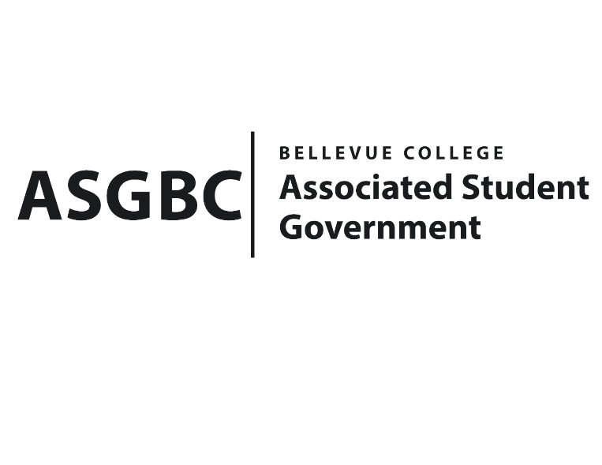
ASG Board of Directors Meeting Agenda
May 3rd, 2024 | B-201 | 12:30-1:30
Next Meeting: May 10th, 2024

- CALL TO ORDER
  - Chair Sean Behl calls the meeting to order at 12:30

- ROLL CALL
  - President: Sean Behl (present)
  - Vice President: Rebecca Mbaka (absent, excused)
  - Executive Justice: Daniel Ngoy (present)
  - Treasurer: Heidi Ngo (present)
  - Secretary: Julie Nguyen (present)
  - Public Relations Rep: Joyce Diakubama (present)
  - Events Rep: Sienna Jarrard (present)
  - Social Responsibility Rep: Stephanie Nehema (present)
  - Emerging Technology Rep: Isadora Silva (present)

- INTRODUCTIONS
  - Michael Kaptik – Dean of Student Life
  - Justin Liao – President of Bellevue College Tech Startup Club
  - Malaika K.Khan – President of Bellevue College South Asian Student Association
  - Zoe Mukaba - Officer of Bellevue College United Nations Association
  - Aizada Gapyrova – Officer of Bellevue College United Nations Association
  - Kendrew Kok - Officer of Bellevue College United Nations Association
- APPROVAL OF AGENDA
  - Daniel Ngoy motions, Julie Nguyen seconds, motion passes by 8-0-0
- APPROVAL OF MINUTES
  - Julie Nguyen motions, Heidi Ngo seconds, motion passes by 8-0-0
- OPEN FORUM
  - There were no Board members interested in participating in open forum.
- REPORTS
  - President
    - The President has been working on the hiring process, election for the Board next year.
    - The President has also been working on Senate and Office hiring process.
    - The President has also been working on WSA legislation Assembly.
    - The President has also been working on finalizing S&A Budget Requests.
  - Vice President
    - The Vice President has been…
  - Executive Justice
    - The Executive Justice has been working on finalizing data gathered from the survey given out to students regarding WSA legislation.
    - The Executive Justice has also been working on planning for the first training session, which will be on April 29th, for students who are interested in learning more about advocating for legislations.
  - Treasurer
    - The Treasurer has been reviewing funding requests and communicating with clubs to make sure all materials are ready for the Board of Directors meeting.
    - The Treasurer has also been working on writing Board Bills for funding requests and club charters.
    - The Treasurer has also been attending SESF meeting.
    - The Treasurer has also been participating in ASG Tabling event, encouraging more people to vote for the President & Vice President for next year.
    - The Treasurer reports $51,540 and $300,649 remaining in the ASG Cultural and General account.
  - Secretary
    - The Secretary has been working on preparing Agendas and Minutes for the Board of Directors meeting.
    - The Secretary has also been working on sending emails recap to clubs regarding ASG decision from last week Board of Directors meeting.
    - The Secretary has also been conducting interviews for the Board of Directors next year.
  - Public Relations Rep.
    - The Public Relations Rep. has been working with citation committee regarding to the parking citations.
    - The Public Relations Rep. has also been helping with the Senate hiring process.
    - The Public Relations Rep. has also been working on advertising for ASGBC Elections.
  - Events Rep.
    - The Events Rep. has been planning and executing ASGBC Voting Elections, Food Truck will be from May 6th-May 9th.
    - The Events Rep. has also been conducting interviews for next year ASG Board of Directors.
    - The Events Rep. has also been working on hiring Senate & the Office positions, the applications are currently open.
    - The Events Rep. has also been working on planning for the Gala, which will be on June 6th.
    - The Events Rep. has also been doing Agendas and taking Minutes for the Senate meeting.
  - Social Responsibility Rep.
    - The Social Responsibility Rep. has been working on tabling for advertising the Senate applications for next year, by reaching out to students and visiting classes.
    - The Social Responsibility Rep. has also been working on attending SESF meeting.
    - The Social Responsibility Rep. has also been working on advertising for ASGBC Elections.
    - The Social Responsibility Rep. has also been working on officer hours and SESF Committee timeline.
  - Emerging Technology Rep.
    - The Emerging Technology Rep. has been working on keeping ASG website updated.
- UNFINISHED BUSINESS
  - Board Bill 03-01-46 - An Act to Approve Funding for the Bellevue College South Asian Student Association Eid Event in the Amount of $4,611.50
- Funds requested will be used to cover printing costs, supplies/materials, food/beverages, and performer costs, estimated for 150 students in C cafeteria for Eid Event.
- Stephanie Nehema motions to amend the amount to $4,631.50, Heidi Ngo seconds, motion passes by 8-0-0
- Julie Nguyen motions to approve the amended amount, Daniel Ngoy seconds, motion passes by 8-0-0
- NEW BUSINESS
  - Board Bill 03-01-48: An Act to Approve Funding for the Bellevue College Model United Nations Conference in the Amount of $4,917.91
- Funds requested will be used to cover printing costs, performer, supplies/materials, food/beverages, venue, and miscellaneous costs. The conference will be hold for 2 days, estimated for 100 students, in U building.
- Stephanie Nehema motions to amend the amount to $5,917.91, Daniel Ngoy seconds, motion passes by 8-0-0
- Daniel Ngoy motions to approve the amended amount, Heidi Ngo seconds, motion passes by 6-0-2
  - Board Bill 04-01-43: An Act to Approve the Charter of the Bellevue College D&D Club.
- Daniel Ngoy motions, Heidi Ngo seconds, motion passes by 9-0-0
  - Senate Bill SB-01-01: A Recommendation to the Board of Directors to Enact Nominal Voluntary Student Fees to Ensure the Sustainability of the Services and Activities Fee Process
- Daniel Ngoy motions, Sienna Jarrard seconds, motion passes by 8-0-1
  - Board Bill 04-01-44: An Act to Enact the Student Legislative Advocacy Fee
- Stephanie Nehema motions to amend the word “minimal” to “flat”, Daniel Ngoy seconds, motion passes by 8-0-0
- Daniel Ngoy motions, Sienna Jarrard seconds, motion passes by 8-0-1
  - Board Bill 04-01-45: An Act to Approve the Services and Activities Fee Committee Recommendation for the 2024-2025 Academic Year
- Sienna Jarrard motions, Heidi Ngo seconds, motion passes by 8-0-0
  - BOARD BILL 03-01-49 - An Act to Approve Funding for the Tech Startup Club’s Food for Meetings in the amount of $777.2.
- Funds requested will be used to cover for club’s weekly meeting food, aiming to advertising the club and having more people being involved.
- Since the timeframe is changed and the inaccurate estimation, the request will be for 12 weeks instead of 14 weeks.
- Sienna Jarrard motions to amend the request to $478.40, Heidi Ngo seconds, motion passes by 5-0-3
- Sienna Jarrard motions to approve the amended amount, Heidi Ngo seconds, motion passes by 6-2-0
  - Board Bill 04-01-46: An Act to Approve the SESF Committee Recommendation to Approve the 2024 BC CSA Pilot Program Extension in the amount of $5,350
- Joyce Diakubama motions, Stephanie Nehema seconds, motion passes by 7-0-3
  - Board Bill 04-01-47: An Act to Approve the SESF Committee Recommendation to Approve the Book Binding Project in the amount of $300
- Julie Nguyen motions, Heidi Ngo seconds, motion passes by 9-0-0
  - Board Bill 04-01-48: An Act to Approve the SESF Committee Recommendation to Approve the Natural and Cultural History of the Upper Skagit Valley (Diablo Lake Tour) in the amount of $2,184
- Daniel Ngoy motions, Heidi Ngo seconds, motion passes by 8-0-1
  - Board Bill 04-01-49: An Act to Approve the SESF Committee Recommendation to Approve the Natural and Garden Club Summer Growing Season project request in the amount of $400
- Daniel Ngoy motions, Heidi Ngo seconds, motion passes by 8-0-1
  - Senate Resolution SR-01-13: A Resolution to Address Rental Costs and Hourly Minimums for Students on the 3rd Floor of the U-Building
- Daniel Ngoy motions, Julie Nguyen seconds, motion passes by 8-0-1
- DISCUSSION ITEMS
  - Senate Resolution SR-01-14: A Resolution to Address Inadequate Access to Athletic Trainers for Student-Athletes
- ANNOUNCEMENTS
  - Sienna Jarrard announces voting event, May 6th-May 9th, 11-2pm in the Courtyard, Food Truck everyday.
  - Sienna Jarrard announces Gala, June 6th, 5-10pm.
- ADJOURNMENT
  - Julie Nguyen motions, Daniel Ngoy seconds, the meeting is adjourned 1:24pm

