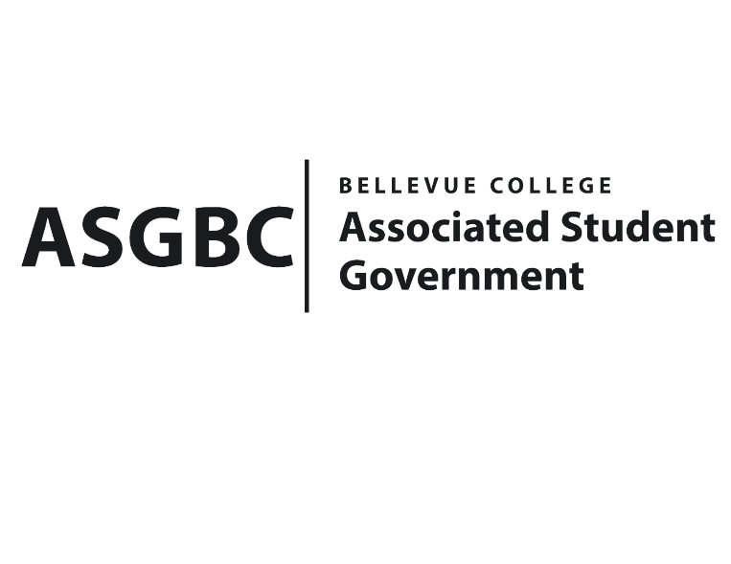
ASG Board of Directors Meeting Minutes
April 26th, 2024 | B-201 | 12:30-1:30
Next Meeting: May 3rd, 2024

- CALL TO ORDER
  - Chair Sean Behl calls the meeting to order at 12:30

- ROLL CALL
  - President: Sean Behl (present)
  - Vice President: Rebecca Mbaka (present)
  - Executive Justice: Daniel Ngoy (present)
  - Treasurer: Heidi Ngo (present)
  - Secretary: Julie Nguyen (present)
  - Public Relations Rep: Joyce Diakubama (present)
  - Events Rep: Sienna Jarrard (present)
  - Social Responsibility Rep: Stephanie Nehema (present)
  - Emerging Technology Rep: Isadora Silva (absent, excused)

- INTRODUCTIONS
  - Michael Kaptik – Dean of Student Life / ASG Co-Advisor
  - Justin Liao – President of Bellevue College Tech Startup Club
  - Habiba Elswify - President of Bellevue College AI & Ethics Club
  - Brandon Lowder – Vice President of Bellevue College Computer Programming Club
  - Ethan Leonard - President of Bellevue College Computer Programming Club
  - Joel Varghese - Secretary of Bellevue College South Asian Student Association
  - Malaika Karam Khan – President of Bellevue College South Asian Student Association
  - Norah Brooks - Officer of Bellevue College Business Leadership Community
  - Isabel Man - Officer of Bellevue College Business Leadership Community
  - Kendrew Kok - Officer of Bellevue College Business Leadership Community
  - Julie Jun – Officer of Bellevue College Business Leadership Community
- APPROVAL OF AGENDA
  - Daniel Ngoy motions, Julie Nguyen seconds, motion passes by (8-0-0)
- APPROVAL OF MINUTES
  - Julie Nguyen motions, Stephanie Nehema seconds, motion passes by (8-0-0)
- OPEN FORUM
  - There were no Board members interested in participating in the open forum.
- REPORTS
  - President
    - The President has been working on the hiring process, election for the Board next year.
    - The President has also been working with Stephanie Nehema on SESF Committee.
    - The President has also been working with Rebecca Mbaka on Cap & Gown Program.
    - The President has also been working on transitioning documents and training for next year team.
  - Vice President
    - The Vice President has been working on finalizing the commencement speaker process, which the official speaker will be announced next week.
    - The Vice President has also been having meeting with the Senators, scheduling class visit to promote more about the Senators to students.
    - The Vice President has also been working and finalizing the Cap & Gown project, so far, we have 32 applications.
  - Executive Justice
    - The Executive Justice has been working on gathering data from the survey given out to students regarding WSA legislation.
    - The Executive Justice has also been working on planning for the first training session, which will be on April 29th, for students who are interested in learning more about advocating for legislations.
  - Treasurer
    - The Treasurer has been workingon reviewing funding requests and communicating with clubs to make sure all materials are ready for the Board of Directors meeting.
    - The Treasurer has also been working on writing Board Bills for funding requests and club charters.
    - The Treasurer has also been working on reviewing S&A budget requests for next year.
    - The Treasurer reports $51,540 and $307,949 remaining in the ASG Cultural and General account.
  - Secretary
    - The Secretary has been working on preparing Agendas and Minutes for the Board of Directors meeting.
    - The Secretary has also been working on sending emails recap to clubs regarding ASG decision from last week Board of Directors meeting.
    - The Secretary has also been helping in ASG Totes & Floats event.
  - Public Relations Rep.
    - The Public Relations Rep. has been working on promoting ASG election voting.
    - The Public Relations Rep. has also been working on conducting interviews for the Board next year.
    - The Public Relations Rep. has also been working on getting clubs funding requests’ scheduls for the update, which will be during Board of Directors meeting in the future.
  - Events Rep.
    - The Events Rep. has been working on planning and executing Candidates Panel for the President and Vice President candidates for next year.
    - The Events Rep. has been working on planning for the ASG Gala, which will be on Jun 6th
    - The Events Rep. has also been conducting interviews for next year ASG Board.
    - The Events Rep. has been working on hiring Senate & the Office positions, the applications are currently open.
    - The Events Rep. has also been working on planning and marketing for election events (tabling, panel, candidate’s debate, and voting process)
    - The Events Rep. has also been working on the Cap & Gown Project.
  - Social Responsibility Rep.
    - The Social Responsibility Rep. has been working on tabling for advertising the Senate applications for next year.
    - The Social Responsibility Rep. has also been working on planning and executing meeting with SESF committee.
    - The Social Responsibility Rep. has also been conducting interviews for the Board next year.
  - Emerging Technology Rep.
    - The Emerging Technology Rep. has been…
- UNFINISHED BUSINESS
- NEW BUSINESS
  - Board Bill 03-01-43 - An Act to Approve Funding for the Bellevue College Business Leadership Community Alumni Night Event in the Amount of $2,800.00
- Funds requested to cover additional expenses for food and entertainment for Alumni Night Event, which will happen in May 22nd, estimated for about 250 people.
- Stephanie Nehema motions, Heidi Ngo seconds, motion passes by (7-0-1)
  - Board Bill 03-01-44 - An Act to Approve Funding for the Bellevue College Business Leadership Community Providence Event in the Amount of $1,200.00
- Funds requested will be used to cover some desserts and beverages for the event, estimated 80 people, which will be in May 7th.
- Julie Nguyen motions, Daniel Ngoy seconds, motion passes by (7-0-1)
  - Board Bill 03-01-45 - An Act to Approve Funding for the Bellevue Computer Programming Club AI Guest Speaker Event in the Amount of $1,225.00
- Funds requested will be used to cover food/beverages for Guest Speaker event, for 75-100 people estimated, on May 17th.
- Heidi Ngo motions, Rebecca Mbaka seconds, motion passes by (8-0-0)
  - Board Bill 03-01-46 - An Act to Approve Funding for the Bellevue College South Asian Student Association Eid Event in the Amount of $4,540.00
- Funds requested will be used to cover printing cost, performer cost, supplies/materials, and food/beverages cost; for 120 students estimated and will be on Jun 15th.
- There is not enough information about the food/beverages and the overestimate der diem rates for the events.
- Daniel Ngoy motions, Heidi Ngo seconds, motion does not pass (0-8-0)
- Sienna Jarrard motions to move the request to next meeting, Heidi Ngo seconds, motion passes by (8-0-0)
  - Board Bill 03-01-47 - An Act to Approve Funding for the Bellevue College Tech Startup Club Meeting in the Amount of $2,983.60
- Funds requested will be used to cover food for club’s meeting, twice a week, and events’ tickets for 25 students each outside campus.
- The Board decided to fund for everything except for the weekly meeting’s food expenses, since it requires further discussion between Board members.
- Joyce Diakubama motions to amend the request to $2075, Daniel Ngoy seconds, motion passes by (6-0-2)
  - Board Bill 04-01-41 - An Act to Ratify the SESF Request for Isla Trip Budget Adjustment of $2500
- Joyce Diakubama motions, Heidi Ngo seconds, motion passes by (7-0-1)
  - Board Bill 04-01-42 - An Act to Approve the SESF Committee Recommendation to Approve the SESF Budget Allocation from the Reserve Account to the Fund Account in the amount of $500,000.
- Sienna Jarrard motions, Julie Nguyen seconds, motion passes by (6-0-1)
  - SR-01-11 – A Resolution to Suggest the Creation of a Student Life Canvas Course.
- Sienna Jarrard motions, Julie Nguyen seconds, motion passes by (6-0-1)
- The Resolution suggest a creation of “Student Life” Canvas course to make accurate student life and campus information access to all.
- Julie Nguyen motions, Heidi Ngo seconds, motion passes by (6-0-1)
  - SR-01-12 – A Resolution to Further Subsidize ORCA Cards and Increase Allocation Amounts.
- Daniel Ngoy motions, Julie Nguyen seconds, motion passes by (6-0-1)
- DISCUSSION ITEMS
  - SR-01-13 – A Resolution to Address Rental Costs and Hourly Minimums for Students on the 3rd Floor of the U-building.
- ANNOUNCEMENTS
  - Sienna Jarrard announces upcoming events:
+ Donuts & Debate – April 30th, Cafeteria, 1-2:30pm
+ Voting Process – May 6th-9th, Courtyard, 11-2:30pm
  - Sean Behl announces that Isadora Silva – Emerging Technology Reps. is selected for 2024 All-Washington Academic Team.
- ADJOURNMENT
  - Rebecca Mbaka motions, Joyce Diakubama seconds, the meeting is adjourned at 1:36

