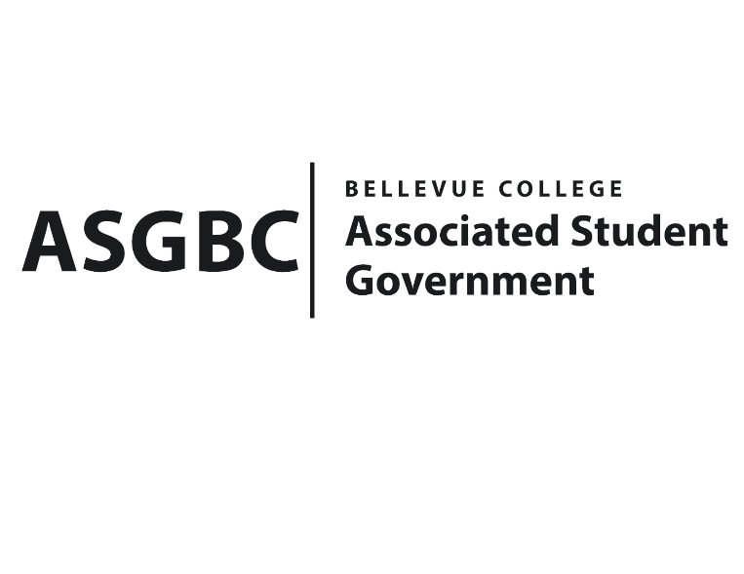
ASG Board of Directors Meeting Agenda
May 10th, 2024 | B-201 | 12:30-1:30
Next Meeting: May 17th, 2024

- CALL TO ORDER
  - Chair Sean Behl calls the meeting to order at

- ROLL CALL
  - President: Sean Behl (present)
  - Vice President: Rebecca Mbaka (present)
  - Executive Justice: Daniel Ngoy (present)
  - Treasurer: Heidi Ngo (present)
  - Secretary: Julie Nguyen (present)
  - Public Relations Rep: Joyce Diakubama (present)
  - Events Rep: Sienna Jarrard (present)
  - Social Responsibility Rep: Stephanie Nehema (present)
  - Emerging Technology Rep: Isadora Silva (present)

- INTRODUCTIONS
  - Name-Title (if applicable)
  - Name-Title (if applicable)

- APPROVAL OF AGENDA

- APPROVAL OF MINUTES

- OPEN FORUM

- REPORTS
  - President
    - The President has been…
  - Vice President
    - The Vice President has been…
  - Executive Justice
    - The Executive Justice has been…
  - Treasurer
    - The Treasurer has been…
  - Secretary
    - The Secretary has been…
  - Public Relations Rep.
    - The Public Relations Rep. has been…
  - Events Rep.
    - The Events Rep. has been…
  - Social Responsibility Rep.
    - The Social Responsibility Rep. has been…
  - Emerging Technology Rep.
    - The Emerging Technology Rep. has been…
- UNFINISHED BUSINESS
- NEW BUSINESS
  - BOARD BILL 03-01-50 - An Act to Approve Funding for the Hong Kong Student Association’s Weekly Food for Meetings in the amount of $1,538.92
  - BOARD BILL 03-01-51 - An Act to Approve Funding for the Posibilities Club’s Event in the amount of $340
  - BOARD BILL 03-01-52 - An Act to Approve Funding for the Stage Fright Drama Club’s Event in the amount of $400.53
  - BOARD BILL 03-01-53 - An Act to Approve Funding for the Tech Startup Club’s Entrepreneurship and AI Event in the amount of $1,500.00
  - BOARD BILL 03-01-54 - An Act to Approve Funding for the Taiwanese Student Association’s Food for Meetings in the amount of $1,018.00
  - Board Bill 04-01-44: An Act to Approve the Charter of the Bellevue College Finance Club.
- DISCUSSION ITEMS

- ANNOUNCEMENTS
  - Board Member announces that…
- ADJOURNMENT

