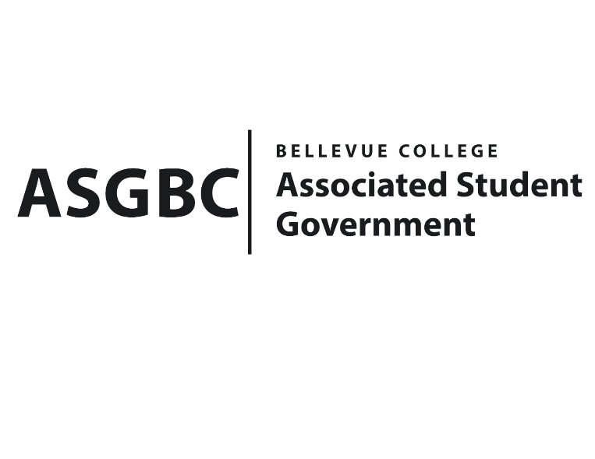
ASG Board of Directors Meeting Agenda
May 3rd, 2024 | B-201 | 12:30-1:30
Next Meeting: May 10th, 2024

- CALL TO ORDER
  - Chair Sean Behl calls the meeting to order at

- ROLL CALL
  - President: Sean Behl (present)
  - Vice President: Rebecca Mbaka (present)
  - Executive Justice: Daniel Ngoy (present)
  - Treasurer: Heidi Ngo (present)
  - Secretary: Julie Nguyen (present)
  - Public Relations Rep: Joyce Diakubama (present)
  - Events Rep: Sienna Jarrard (present)
  - Social Responsibility Rep: Stephanie Nehema (present)
  - Emerging Technology Rep: Isadora Silva (present)

- INTRODUCTIONS
  - Name-Title (if applicable)
  - Name-Title (if applicable)

- APPROVAL OF AGENDA

- APPROVAL OF MINUTES

- OPEN FORUM

- REPORTS
  - President
    - The President has been…
  - Vice President
    - The Vice President has been…
  - Executive Justice
    - The Executive Justice has been…
  - Treasurer
    - The Treasurer has been…
  - Secretary
    - The Secretary has been…
  - Public Relations Rep.
    - The Public Relations Rep. has been…
  - Events Rep.
    - The Events Rep. has been…
  - Social Responsibility Rep.
    - The Social Responsibility Rep. has been…
  - Emerging Technology Rep.
    - The Emerging Technology Rep. has been…
- UNFINISHED BUSINESS
  - Board Bill 03-01-46 - An Act to Approve Funding for the Bellevue College South Asian Student Association Eid Event in the Amount of $4,611.5x
- NEW BUSINESS
  - Board Bill 03-01-48: An Act to Approve Funding for the Bellevue College Model United Nations Conference in the Amount of $4,917.91
  - Board Bill 04-01-43: An Act to Approve the Charter of the Bellevue College D&D Club.
  - Senate Bill SB-01-01: A Recommendation to the Board of Directors to Enact Nominal Voluntary Student Fees to Ensure the Sustainability of the Services and Activities Fee Process
  - Board Bill 04-01-44: An Act to Enact the Student Legislative Advocacy Fee
  - Board Bill 04-01-45: An Act to Approve the Services and Activities Fee Committee Recommendation for the 2024-2025 Academic Year
  - BOARD BILL 03-01-49 - An Act to Approve Funding for the Tech Startup Club’s Food for Meetings in the amount of $777.2.
  - Board Bill 04-01-46: An Act to Approve the SESF Committee Recommendation to Approve the 2024 BC CSA Pilot Program Extension in the amount of $5,350
  - Board Bill 04-01-47: An Act to Approve the SESF Committee Recommendation to Approve the Book Binding Project in the amount of $300
  - Board Bill 04-01-48: An Act to Approve the SESF Committee Recommendation to Approve the Natural and Cultural History of the Upper Skagit Valley (Diablo Lake Tour) in the amount of $2,184
  - Board Bill 04-01-49: An Act to Approve the SESF Committee Recommendation to Approve the Natural and Garden Club Summer Growing Season project request in the amount of $400
  - Senate Resolution SR-01-13: A Resolution to Address Rental Costs and Hourly Minimums for Students on the 3rd Floor of the U-Building
- DISCUSSION ITEMS
  - Senate Resolution SR-01-14: A Resolution to Address Inadequate Access to Athletic Trainers for Student-Athletes
- ANNOUNCEMENTS
  - Board Member announces that…
- ADJOURNMENT

