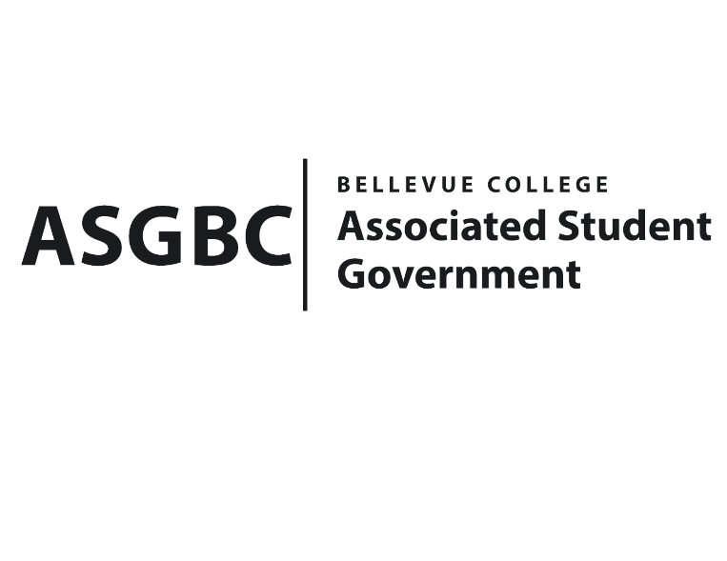
BOARD OF DIRECTORS
Session I
Date: May 3rd, 2024
04-01-49

Submitted by Stephanie Nehema, Social Responsibility Representative

BOARD BILL 04-01-49: An Act to Approve the SESF Committee Recommendation to Approve the Natural and Garden Club Summer Growing Season project request in the amount of $400.

WHEREAS: The Garden Club aims to provide an inclusive space for students and staff to collaborate and learn about the process of growing food from seed to plate; and,

WHEREAS: The Summer Growing Season Project will serve as a valuable educational opportunity for club members, empowering them with the knowledge and skills needed to cultivate their own food in an environmentally responsible manner; and,

WHEREAS: Participating students will be encouraged to reflect on their observations and takeaways through a one-page written reflection, with media materials collected for further dissemination by the Office of Sustainability and Student Engagement; and,

WHEREAS: The requested funding of $400 will support the acquisition of materials necessary for the Garden Club's Summer Growing Season Project, enabling participants to engage in hands-on learning experiences and contribute to the promotion of environmental sustainability on campus; and,

WHERAS: The Natural and Garden Club Summer Growing Season Project was reviewed and approved by the SESF Committee on April 29th, 2024, with a vote in favor of allocating $400.

THEREFORE, BE IT ENACTED BY THE ASSOCIATED STUDENT GOVERNMENT OF BELLEVUE COLLEGE BOARD OF DIRECTORS

THAT: The SESF Committee's recommendation to approve the Natural and Garden Club Summer Growing Season Project Request in the amount of $400 be ratified by the Board of Directors.

THAT: A copy of this bill be forwarded to Sara Holzknecht, Director of Sustainability; Elissa Gordon, Associate Director of Sustainability; Julie Nguyen, ASG Secretary; and Stephanie Nehema, ASG Social Responsibility Representative.

End

I, Sean Behl, President of the Associated Student Government of Bellevue College, do hereby certify that Board Bill 04-01-49 was duly approved by the Board of Directors on 05/03/2024. I attest to the accuracy and authenticity of the contents of this bill.



__________________________________
Sean Behl
ASG President

