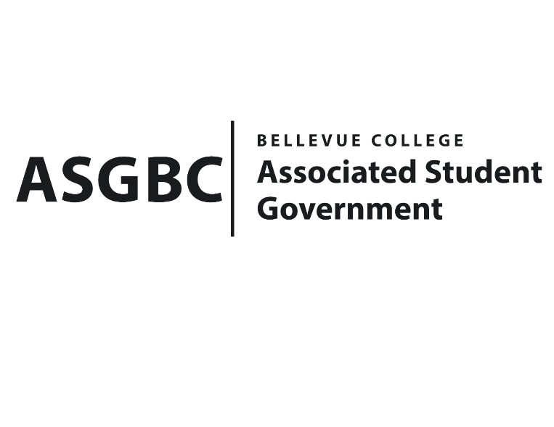
BOARD OF DIRECTORS
Session I
Date: May 3rd, 2024
04-01-45

Submitted by Sean Behl, President

BOARD BILL 04-01-45: An Act to Approve the Services and Activities Fee Committee Recommendation for the 2024-2025 Academic Year

WHEREAS: The Services and Activities Fee (S&A) committee spent a great deal of time reviewing all applications and the committee has come to its final recommendations for 24-25 allocations after completing the appeals process; and,

WHEREAS: The 2024-25 S&A committee reviewed the applications with the following priorities:
- The review of requests and allocations should allow for sustainable fund use this upcoming fiscal year and in future years beyond the current review cycle.
- Use of funds for travel and food should be sustainable and not impede other priorities.
- The function/ organization has been actively using funds to engage students in the past academic year.
- The function/ organization has enriched student life and experience outside of class.
- The function/ organization increases student life and engagement on-campus.
- The opportunity helps students’ academic success, this includes current and future academic success.
- There is an equity component to the request and DEI is factored into request.

WHEREAS: The S&A committee needed to reduce $1,942,269.69 from requests to meet the available fund amount, and reductions were made in travel funds and overall requests based on the committee’s priorities; and,

WHEREAS: The 2024-25 S&A committee decided to separate funds requested for travel from each request in the committee’s overall review, with the remaining travel funds of $551,342.31 being placed in a centralized account from which groups can request approval for use during the 24-25 school year ($156,000 dollars of travel was kept in Athletics and ASG’s budgets); and,

WHEREAS: The Services and Activities Fee committee has forwarded its final recommendation [1] to the President’s Cabinet and the ASGBC Board of Directors for review and approval.

THEREFORE, BE IT ENACTED BY THE ASSOCIATED STUDENT GOVERNMENT OF BELLEVUE COLLEGE BOARD OF DIRECTORS

THAT: The Associated Student Government of Bellevue College hereby approves the 2024-2025 Services and Activities Fee Committee Recommendation in the amount of $7,760,879.31; and,

THAT: A copy of this bill be forwarded to Mike Kaptik, Dean of Student Life and Leadership/ASG Advisor; and Alicia Keating Polson, Executive Director of the President’s Office.

End

References
- 2024-2025 Services and Activities Fee Committee Recommendation

I, Sean Behl, President of the Associated Student Government of Bellevue College, do hereby certify that Board Bill 04-01-45 was duly approved by the Board of Directors on 05/03/2024. I attest to the accuracy and authenticity of the contents of this bill.



__________________________________
Sean Behl
ASG President

