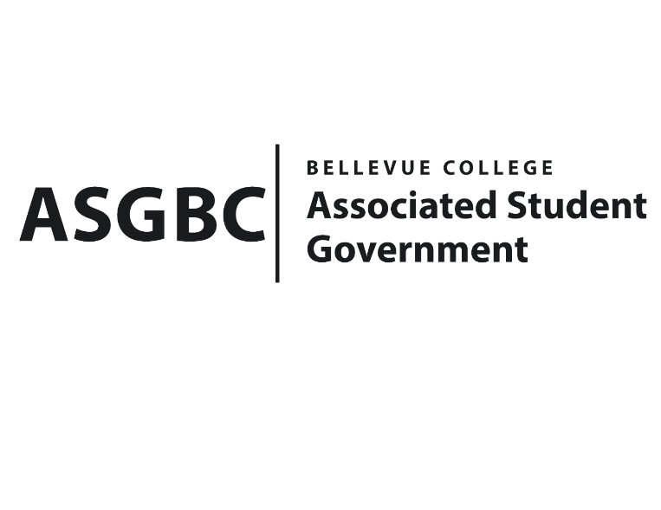
BOARD OF DIRECTORS
Session I
Date: May 3rd, 2024
04-01-44

Submitted by Sean Behl, President

BOARD BILL 04-01-44: An Act to Enact the Student Legislative Advocacy Fee
WHEREAS: The ASGBC Board of Directors intends to enact a voluntary student fee of $3.00 per each Bellevue College student, per quarter to support the legislative advocacy efforts of the ASGBC on behalf of all students at Bellevue College; and,

WHEREAS: The Student Legislative Advocacy Fee will directly support the operations of the ASGBC Office of Civic Engagement which coordinates all student legislative advocacy efforts on campus, including voter registration efforts, and lobbying efforts for all BC students at the local, state, and federal levels; and,

WHEREAS: The Student Legislative Advocacy Fee will also fully support the membership dues of the Washington Student Association (WSA) which is the largest student-led coalition in the state, and provides vital resources, and legislative training to all member campuses; and,

WHEREAS: Our relationship with the WSA is imperative to our legislative efforts, as the ASGBC fights for all Bellevue College students at the local, state, and federal levels each year and relies on their training, support, and resources to do so; and,

WHEREAS: Many other student government associations from across Washington State have enacted similar fees including Western Washington University, Central Washington University, and the University of Washington; and,

WHEREAS: RCW 28B.15.610 clearly states that “Students are authorized to create or increase voluntary student fees for each academic year when passed by a majority vote of the student government or its equivalent;” and,

WHEREAS: RCW 28B.15.610 clearly states that “voluntary student fees imposed under this section and services and activities fees may be used for lobbying by a student government association or its equivalent and may also be used to support a statewide or national student organization or its equivalent that may engage in lobbying;” and,

WHEREAS: The ASGBC Student Senate through Senate Bill SB-01-01 has recommended that the ASGBC Board of Directors take action to address the sustainability of the services and activities fee process through the enactment of nominal voluntary student fees and other measures.

THEREFORE, BE IT ENACTED BY THE ASSOCIATED STUDENT GOVERNMENT OF BELLEVUE COLLEGE BOARD OF DIRECTORS

THAT: The Associated Student Government of Bellevue College Board of Directors hereby enacts the Student Legislative Advocacy Fee to be collected at $3.00 per each Bellevue College student, per quarter beginning in fall quarter 2024; and,

THAT: The Associated Student Government of Bellevue College (ASGBC) and the Administration of Bellevue College (BC) (collectively “the Parties”) establish an agreement to memorialize the terms, conditions, and procedures governing the collection and administration of the Student Legislative Advocacy Fee and,

THAT: A copy of this bill be sent to Mike Kaptik, Dean of Student Life and Leadership; and Alicia Keating Polson. Executive Director of the President’s Office.

End

I, Sean Behl, President of the Associated Student Government of Bellevue College, do hereby certify that Board Bill 04-01-44 was duly approved by the Board of Directors on 05/03/2024. I attest to the accuracy and authenticity of the contents of this bill.



__________________________________
Sean Behl
ASG President

