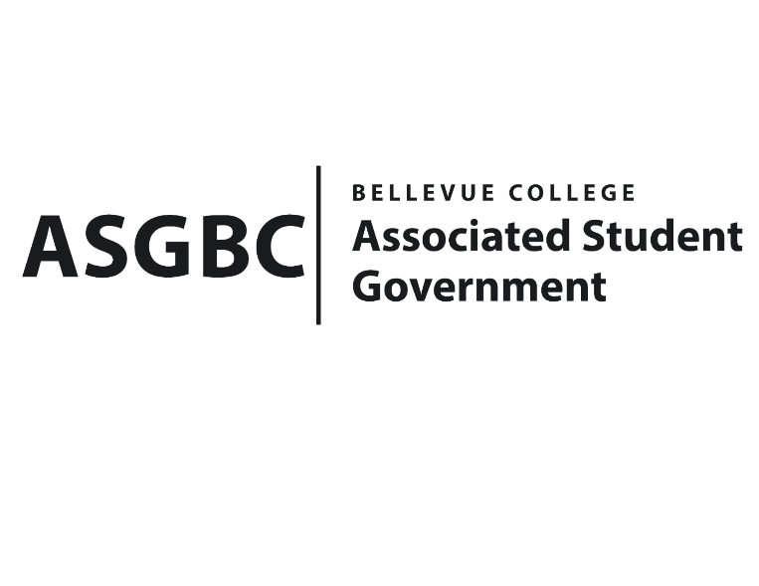
BOARD OF DIRECTORS
Session I
Date: April 26th , 2024
04-01-41

Submitted by Stephanie Nehema, Social Responsibility Representative

BOARD BILL 04-01-41: An Act to Ratify the SESF Request for Isla Trip Budget Adjustment of $2500

WHEREAS: The ISLA Urbana Summer Program budget request aims to improve water access for households, schools, and health clinics by installing rainwater harvesting systems.; and,

WHEREAS: The ISLA budget Adjustment proposal aims to address an oversight in the previous budget allocation by including additional funds specifically for airfare expenses, which were not covered in the initial request; and,

WHEREAS: The ISLA budget Adjustment consists of an additional $2,500 to be added to the previously approved budget of $28,000, totaling $30,500 to cover transportation, accommodation, meals, and airfare for students participating in the ISLA budget trip; and,

WHEREAS: The ISLA Trip Budget Adjustment was reviewed and approved by the SESF Committee on April 23rd, 2024, by a vote of (7-0-1).

THEREFORE, BE IT ENACTED BY THE ASSOCIATED STUDENT GOVERNMENT OF BELLEVUE COLLEGE BOARD OF DIRECTORS

THAT: The SESF Isla Trip Budget Adjustment of $2500 be hereby ratified by the Board of Directors; and,

THAT: A copy of this bill be forwarded to Sara Holzknecht, Director of Sustainability; Elissa Gordon, Associate Director of Sustainability; Julie Nguyen, ASG Secretary; and Stephanie Nehema, ASG Social Responsibility Representative.

End

I, Sean Behl, President of the Associated Student Government of Bellevue College, do herby certify that Board Bill 04-01-41 was duly approved by the Board of Directors on 04/26/2024. I attest to the accuracy and authenticity of the contents of this bill.


__________________________
Sean Behl
ASG President

