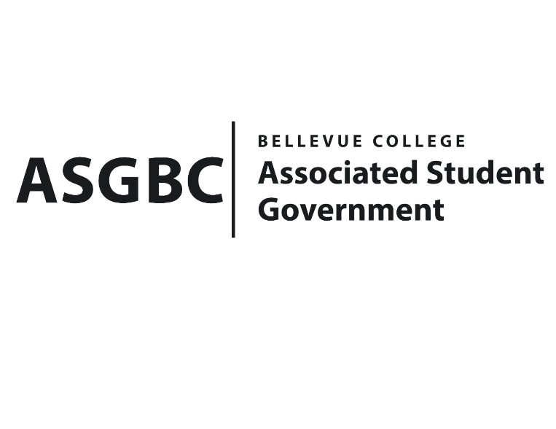
BOARD OF DIRECTORS
Session I
Date: April 19th, 2024
04-01-39

Submitted by Heidi Ngo, Treasurer

BOARD BILL 04-01-39: An Act to Approve the Charter of the Bellevue College Hong Kong Association.

WHEREAS: The Bellevue College Hong Kong Student Association is a vibrant and inclusive community established to unite students from Hong Kong and those interested in their rich culture, traditions, and current affairs who are now studying at Bellevue College. Their mission is to foster a supportive network that bridges the gap between Hong Kong and the US promoting cultural exchange, understanding, and friendship among students of diverse backgrounds; and

WHEREAS: The Bellevue College Hong Kong Student Association intends to highlight the rich heritage of Hong Kong, showcasing its unique blend of Eastern and Western influences through proposed events such as cultural festivals and language exchange workshops. These activities are designed to provide both Hong Kong students and those curious about its culture with opportunities to explore and celebrate the territory's dynamic spirit; and

WHEREAS: The Bellevue College Hong Kong Student Associations plans to support their members academically and professionally. They aspire to create mentorship programs, networking events, and career workshops tailored to assist students in navigating their academic pursuits in the US while also maintaining a strong connection to Hong Kong. Their goal is to offer a supportive network that fosters personal growth, professional development, and a sense of community among our members; and

WHEREAS: The Bellevue College Hong Kong Student Association will welcome anyone interested in learning about Hong Kong, its people, and its culture. They envision our association as a nurturing space where members can find friendship, support, and a sense of belonging, making their time in the US both enriching and memorable. Join us in creating an inclusive community that celebrates the unique cultural tapestry of Hong Kong and fosters lasting connections across the globe.

WHEREAS: The Bellevue College Hong Kong Student Association has met all required qualifications to become a chartered student organization; and

WHEREAS: This charter shall expire on June 30th, 2024, unless otherwise renewed by the club with ratification from the Board of Directors.

THEREFORE, BE IT ENACTED BY THE ASSOCIATED STUDENT GOVERNMENT OF BELLEVUE COLLEGE BOARD OF DIRECTORS

THAT: The Associated Student Government hereby recognizes the Bellevue College Hong Kong Student Association as an official student organization at Bellevue College; and

THAT: A copy of this bill be forwarded to Julie Nguyen, ASG Secretary; Joyce Diakubama, ASG Public Relations Representative; Amanda Arboleda, Student Engagement- Student Involvement Specialist; Cheuk Lam Kam, Bellevue College Hong Kong Student Association President; and Sophie Leung, Bellevue College Hong Kong Student Association Advisor.

End

I, Sean Behl, President of the Associated Student Government of Bellevue College, do herby certify that Board Bill 04-01-39 was duly approved by the Board of Directors on 04/19/2024. I attest to the accuracy and authenticity of the contents of this bill.


__________________________
Sean Behl
ASG President

