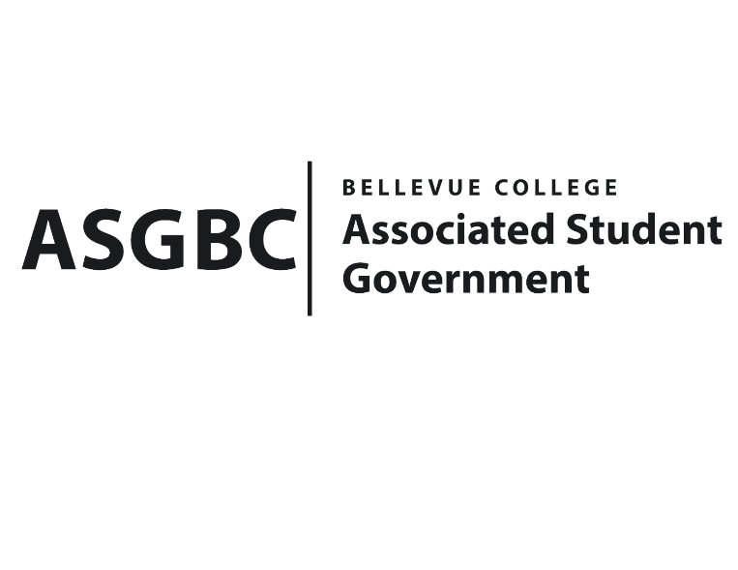
BOARD OF DIRECTORS
Session I
Date: May 3rd, 2024
03-01-49

Submitted by Heidi Ngo Treasurer

BOARD BILL 03-01-49 - An Act to Approve Funding for the Tech Startup Club’s Food for Meetings in the amount of $478.40.

WHEREAS: The Bellevue College TechStartup Club plans to have weekly meetings, where they teach students in tech entrepreneurship, and provide student the time to connect members with food, students will be able to learn from other students in different fields members and increase the diversity; and

WHEREAS: The Bellevue College TechStartup Club will support their mission by having meetings where they work on projects together, fostering innovation and creativity among BC students.

THEREFORE, BE IT ENACTED BY THE ASSOCIATED STUDENT GOVERNMENT OF BELLEVUE COLLEGE BOARD OF DIRECTORS

THAT: The Associated Student Government of Bellevue College approves the allocation of $478.40 to fund the Bellevue College Tech Startup Club’s Association funding request; and

THAT: The approved funding is allocated from the ASG General account; and,

THAT: A copy of this bill be forwarded to Heid Ngo, Treasurer and Hristo Stoynov, Office of Student Engagement Program Coordinator, Joseph Hueffed, The Bellevue Tech Startup Club Advisor, and Kuan-Ying Liao, The Bellevue College Tech Startup Club President.
End

I, Sean Behl, President of the Associated Student Government of Bellevue College, do herby certify that Board Bill 03-01-49 was duly approved by the Board of Directors on 05/03/2024. I attest to the accuracy and authenticity of the contents of this bill.


__________________________________
Sean Behl
ASG President

